**IMPLEMENTATION PHASE**

In the implementation phase, this work start writing the actual coding process for each functional requirement, applying the iterative and incremental methodology to jump to the next requirement. The ASP.net and C# programing language have been used to achieve many advantages and match the functional and nonfunctional requirements ,such as the Suitability ,Integration , portability and development speed .Then testing each link, every form , every SQL script and C# coding . The code testing process was used to make sure that the code created in the previous step fully complies with modern web standards.

To get started using the proposed QS system, the user needs to select tasks from specific list control. For each calculation, it is necessary to enter the required parameters and data, such as, structure dimensions; the required strength characteristics; location region, and so on. Most calculations involve several directions, in addition to the basic calculation of building materials; it is possible to calculate the size of the structure. Each calculation is provided with additional reference materials, indicating the cost of one unit of material, the calculator will calculate the total cost of all the necessary quantities. Calculation of additional indicators is carried out with a tick marked opposite the point of interest. The result of the calculation instantly appears on the screen after pressing the "Calculate" button. The calculators presented on the site minimize the task of long calculations to a minimum, which saves considerable time. Each section and subsection of the Web-based allows: choose the proposed types of work; calculate the necessary costs and the amount of material required for the work; read the detailed drawing from the uploaded files; calculate the total amount for building materials; to get acquainted with reference materials and recommendations; the proposed system allows the user to print the result of calculations or download the results as an excel, Word or PDF file respectively. The complete description of the system interface and their use are included in appendix A and a sample of the code included in Appendix B.

**REAL EXAMPLE OF THE DEVELOPMENT SYSTEM**

|  |  |
| --- | --- |
| **User Requirement :** | Calculate the Steel needed for the foundation including the plinth beam |

First, this work studied the paper work done by the QS engineer to understand the process of the calculation. Figure 4.11 shows samples of real paper work done for a building in Sohar area in Sultanate of Oman, related to the Burooj Al-Aqeer ModrenTrdg L.L.C construction company. Samples of the manual work collected from the construction company are described in figure 4.11 and the rest are included in appendix C. The building area information described in figure 4.12.

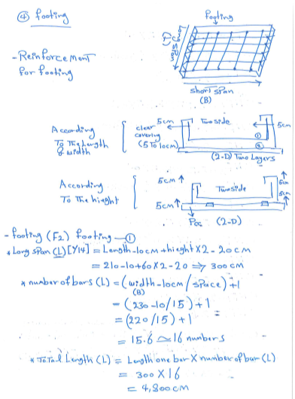

**Figure 4.11** Sample ofpaper work

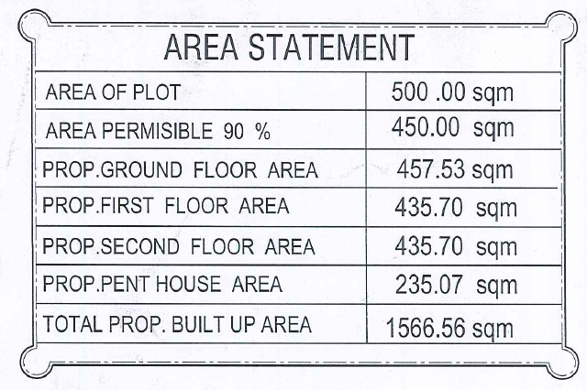

**Figure 4.12** Building area information

Figure 4.13 shows the acceptance latter from the building company. The letter stated that the “Burooj Al-AqeerModrenTrdg L.L.C” building company located in Sohar is certified their approval by allowing Mr. SaifNabhan Abdul Majeed, to perform the QS calculation for the building that located in sohar at suq al-multaqa, without affecting the progress of the current work.

|  |  |
| --- | --- |
|  |  |

**Figure 4.13** Acceptance Letter

The company later provide many documents in hard copy format, related to their building. The construction map is demonstrated in figure 4.14, the specification of construction prepared by the consultant company for Sub-structure & Super-Structure, described in figure 4.15, and the paper work which prepared by the QS engineer described in figure 4.11 above, the document describes the real calculation for the Sub-structure & Super-Structure. The documents consist of 133 pages and each page consist approximately of ~30 lines. The QS engineer, who is responsible for preparing the QS calculation document, stated that they struggle from such calculation approach. Because the manual calculation, causes many inconveniences and raise many human errors when entering the data to excel. In addition to that the deadlines of completing the calculation on time which also cause many pressures and tension to complete the QS calculation on time, and without mistakes. Furthermore some mistakes could by very serious which could lead to a major loses in their business , which also could lead to release many QS engineers from their job positions and causes also serious delay in completing the project on time. Thus, it’s important to solve the raises problems by replacing the use of Excel and paper work in the QS process, using the proposed solution by, automating the process of the paper work prepared by the QS engineers. The proposed solution is presented in the form of web application “Web-Based Framework for Implementation of Quantities Survey”.

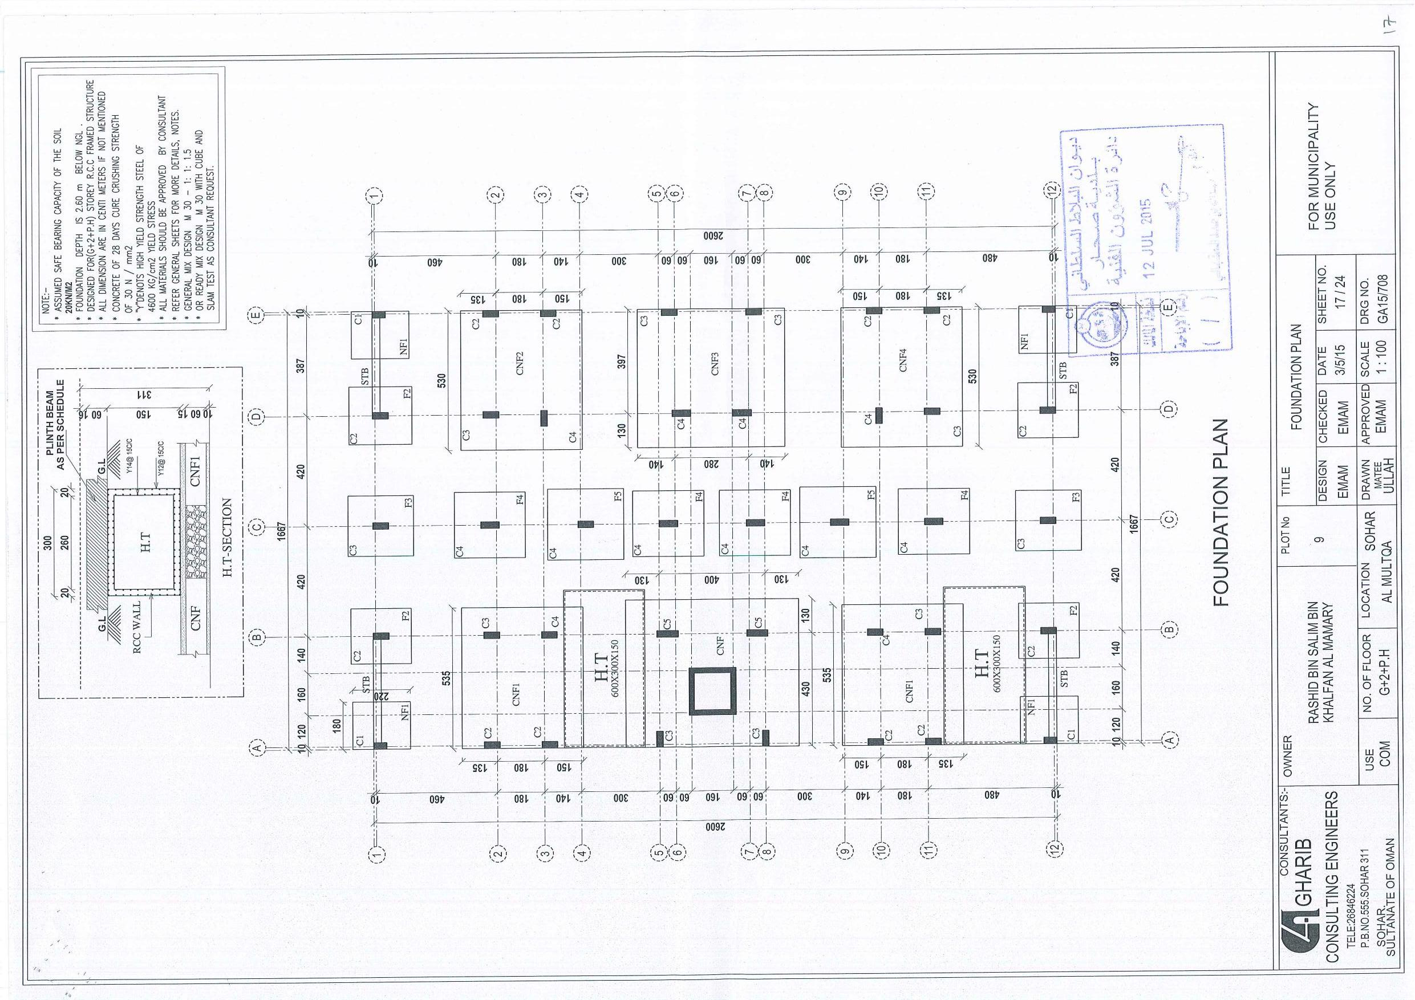

**Figure 4.14** Construction Maps

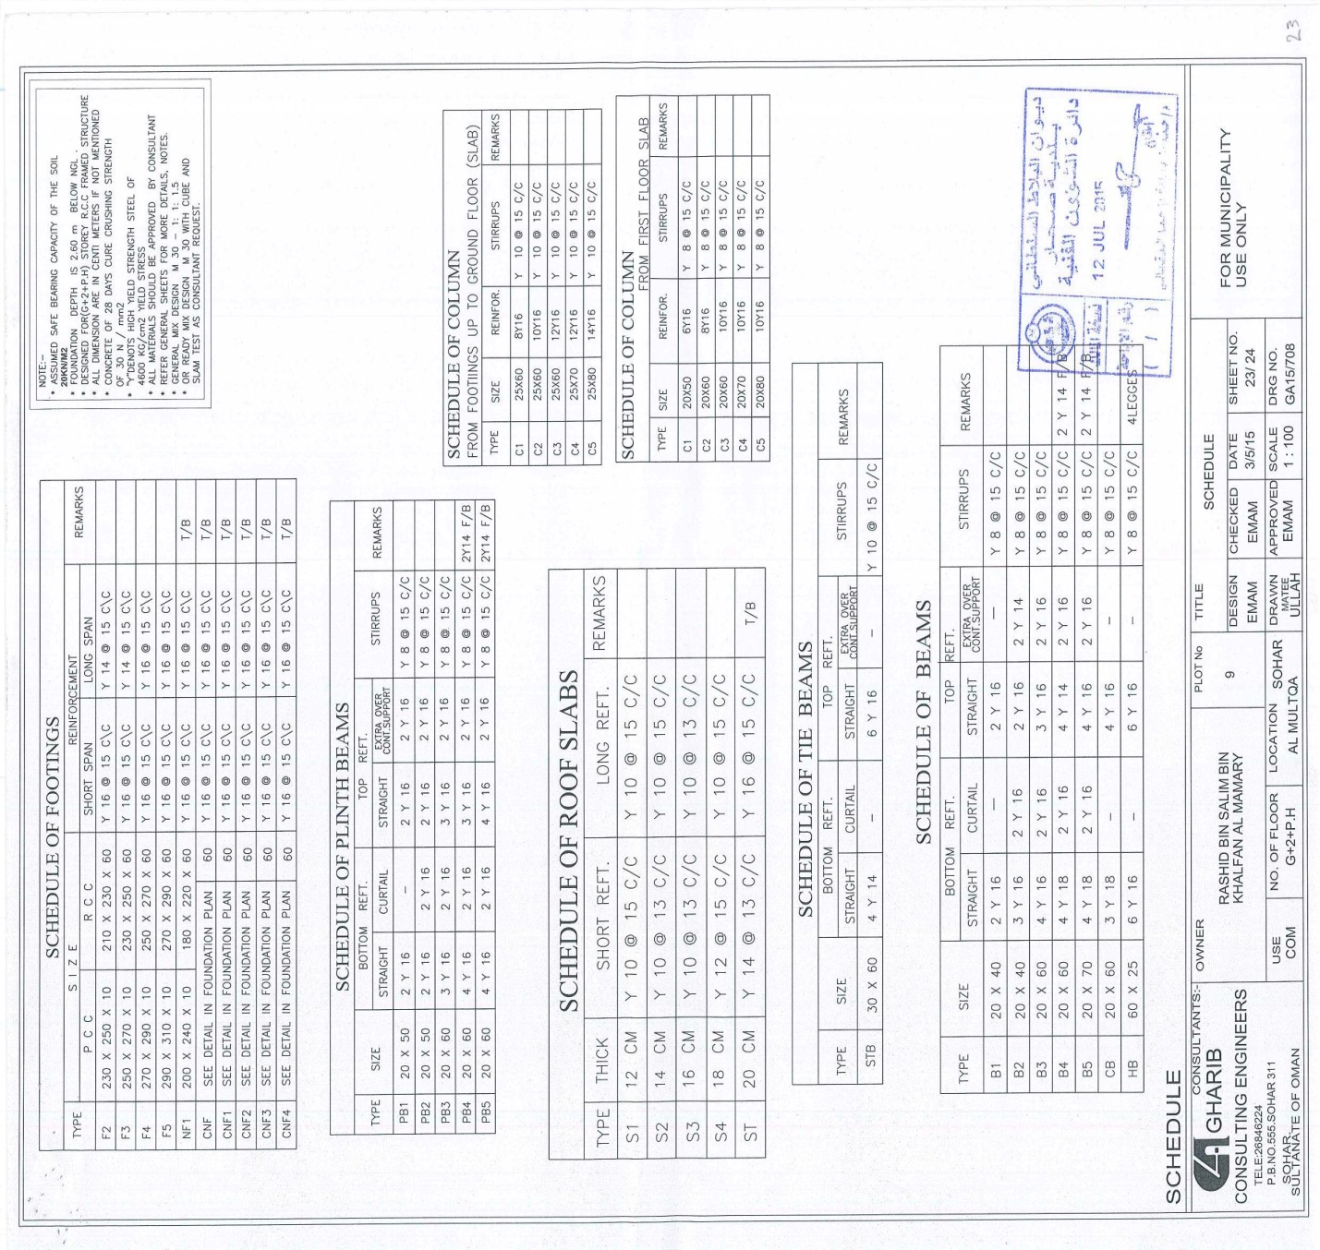

**Figure 4.15** Consultant Specifications (Sub-structure & Super-Structure.

To show a clear picture for the benefits and the value of the proposed work, this work provides the following description of automation the footing process. The footing process described in paper work, the sample is included in figure 4.11.The first step was to consider the consultant report that provide the specification of calculating the footing process, Figure 4.16 described the footing specification related to the footing process.

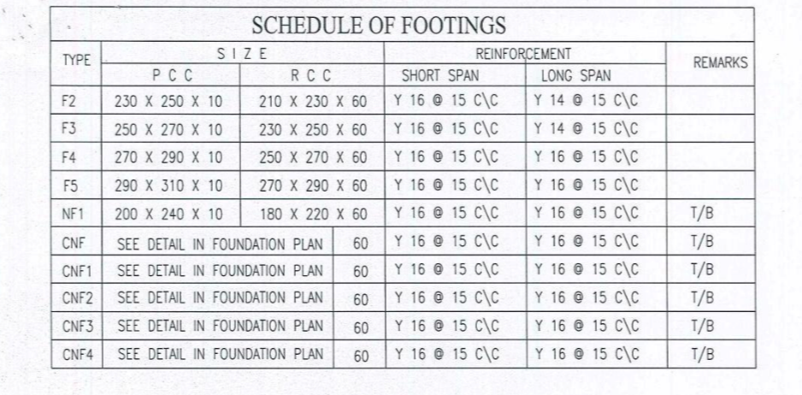

**Figure 4.16** Footing Specification

To enable the automation process, first of all, this research studied the paper work and the available documents, the specifications and other documents related to complete the footing calculation. The table structure has been created with the related fields in the main database schema, to represent the footing specification data. Figure 4.17 shows the structure of the footing table considering the specification described in figure 4.15.

Allow the user to add new record

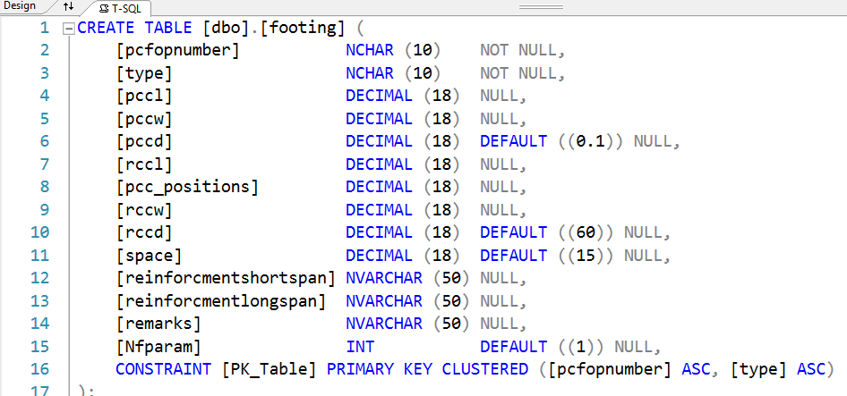

**Figure 4.17** Footing Table Structure

Figure 4.17 describes the table title which is ‘Footing’ and the Filed names are described within the figure.

|  |  |  |  |
| --- | --- | --- | --- |
| **Table 4.3** | | | |
| Fields description for footing table | | | |
|  | | | |
| Field name | Description | Matching | More details |
|  |  | with footing specification (figure4.14) |  |
| [pcfopnumber] | Project number to recognize projects | Non | Each project should identified by a unique number, to facilitate the search and indexing operation for various project. |
| [type] | Footing type | type |  |
| [pccl] | Footing Length | PCC SIZE (L) |  |
| [pccw] | Footing Width | PCC SIZE (W) |
| [pccd] | Footing Depth | PCC SIZE (D) |
| [rccl] | Reinforcement Length | RCC SIZE (L) |  |
| [rccw] | Reinforcement Width | RCC SIZE (W) |
| [rccd] | Reinforcement Hieght | RCC SIZE (H) |
| [pcc_positions] | Number of positions | Specified by the standards and the consultant for each type | F2 : 4 positions  F3: 2 positions  etc.. |
| [space] | Footing Space for calculating | Footing Space for calculating the number of bars | Extracted from Reinforcement short span and long span |
| [reinforcmentshortspan] | Reinforcement short span | Reinforcement specification for steel Y16 or Y14 |  |
| [reinforcmentlongspan] | Reinforcement long span |
| [remarks] | Note | For additional specification | Details in the foundation Plan |
| [Nfparam] | Number of layer | Layer number for “NF” =2 |
|  | | | | |

After creating the footing table, all related controls have been developed using the Integrated Development Environment(IDE) in visual studio, to facilitate the data entry, the controls are described in figure 4.18 for data entry and figure 4.19 to demonstrate the calculation results in one click.

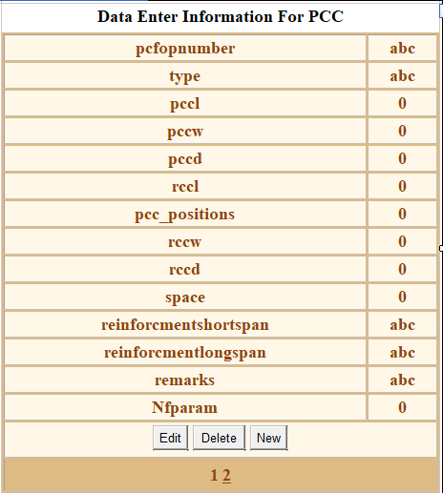

**Figure 4.18** Footing data entry control

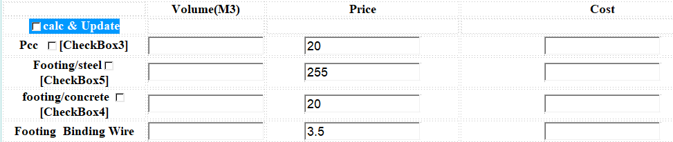

**Figure 4.19** Footing results

After identifying the required controls, the coding process started. SQL script and ASP.net &C# coding have been used to perform the automation process for the required footing calculation described in the paper work. See figure 4.11.

When the user start entering the data in the data entry control “detail view”, to facilitate the data entry for the purpose of reducing data entry error, there is a feature that allow the user to upload the data files that specified by the consultant during the data entry, figure 4.20 show this feature.

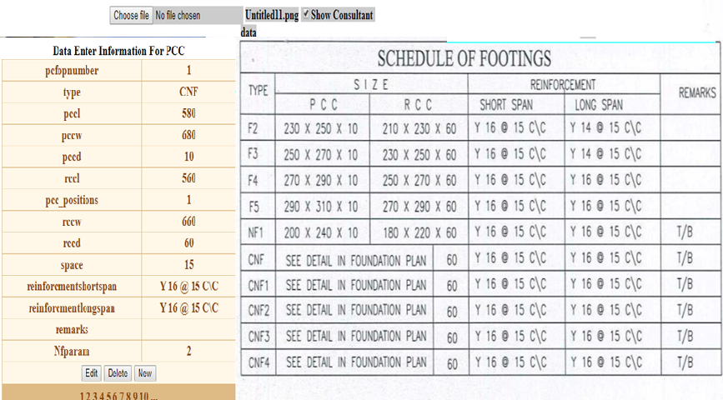

**Figure 4.20** uploading file for data entry.

the system start automatically triggering the SQL script and the results for each operation were displayed in specific control “grid view control”, the following figures demonstrate the details of the footing calculations, this have been done to give the QS engineers more details on how the system generate the output results . All calculation was implemented without the user intervention. Table 4.6 shows complete picture about footing implementation.

|  |  |
| --- | --- |
| **Table 4.4** | |
| Details of footing implementation | |
|  | |
| **Grid view Control(generating dynamic data)** | **SQL SCRIPT and Related Table** |
|  |  |
| Displaying footing data during the data entry process ,and calculating the total quantity of concrete for PCC for all types **(saving 60 lines of paper work calculation by the user)** | |
|  |  |
| Demonstrated the details of Calculating the reinforcement for footing short span and long span, calculating the number of bars and total length for short and long span, finally generate the total concrete quantity required for each reinforcement type **.(saving 510 lines of paper work calculation by the user** | |
|  |  |

|  |  |
| --- | --- |
| Project information Form | Related table |
|  |  |
|  |  |

**Figure4.1** Project registration form

The Project registration form demonstrated the Initial step of completing the QS Tasks,

The user needs, to register the project and to enter main information about the project , the information linked to the main database with table name called “projectinfo”, Therefore to keep the various projects secure and managed and easy to access considering ‘CRUD’ operations i.e. Create, Read, Update and Delete ,So only the correct project will be effected after the CRUD operation .

|  |  |
| --- | --- |
|  |  |
|  |  |

**Figure4.2** Project Log In screen

The Log In screen demonstrated to perform the security function for validating the authorized user to access their related project and to offer the correct environment to the related project.

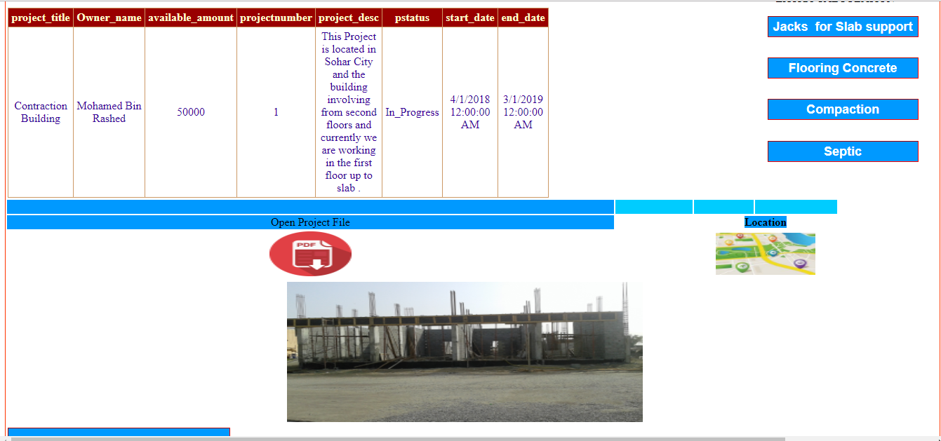

**Figure 4.3** Project Basic Information web page

The Project Basic Information web page shows the main information from table ‘project info’, that have been entered in Figure 4.1 Project registration form,

The user could captured the basic project information as well as can read the project information file that have been attached to the project

The user also could access the location of the project , based on the project Image that have been taken from the real project location .

When the user click the “open Project File ” Icon the project file opened in a pop up screen as shown in figure 4.4

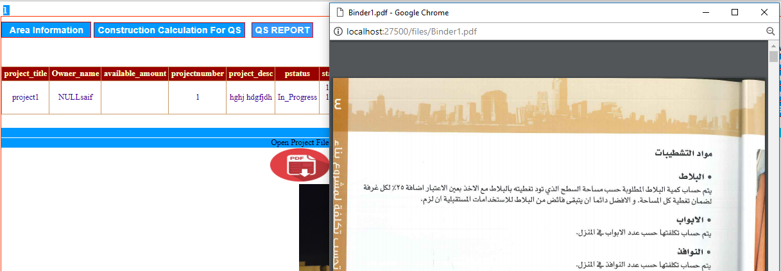

**figure 4.4** Open attached file screen

When the user click the location image the system will identify and extract the Image location information and pass it to google map satellite to show the location of the project ,Figure 4.5 display a sample of discovering the project location

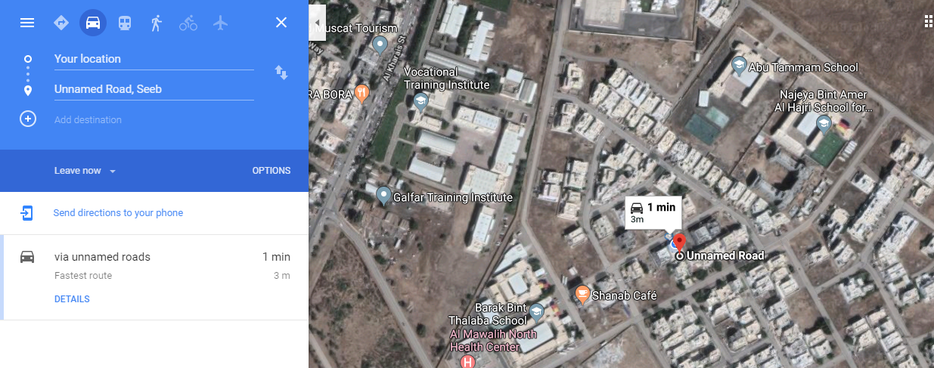

**Figure 4.5** Locating the project location screen

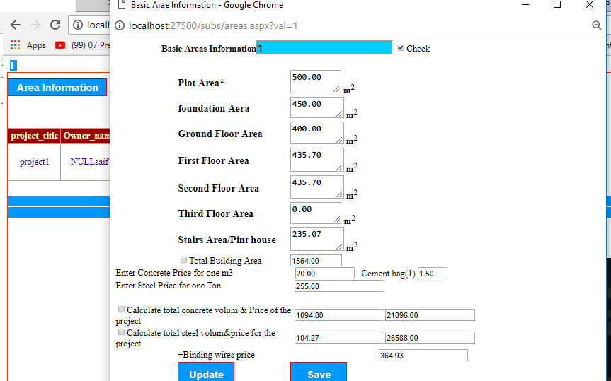

**Figure 4.6** Project Area and main price information

The user start with entering building Areas using Area web page as described in figure 4.6 , this screen allow the user to save the information and update when its necessary ,for example when the price changed etc…

After entering the project areas information the user can generate the first QS report as described in figure 4.7 ,the information that demonstrated in the firs report are not accurate to be used as a final QS report , this is just a report that generated based on previous projects with similar areas information ,however such approach is not recommended since there are many nuances related to the QS which could play main role in affecting the QS report information .

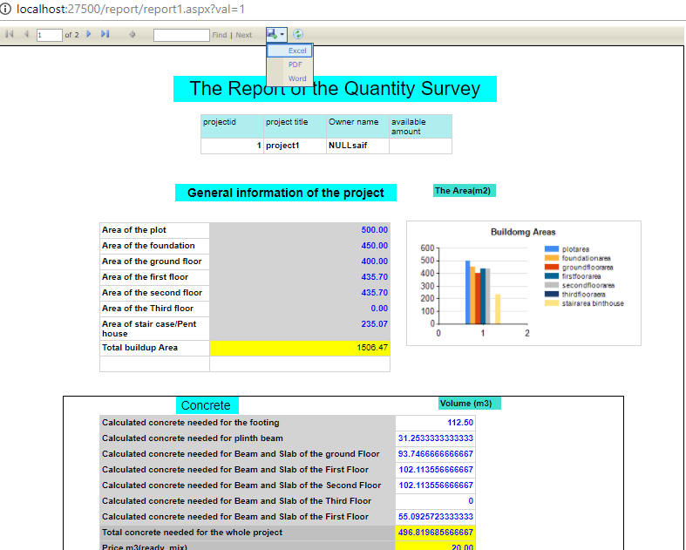

**Figure 4.7** Predicted QS first report

As shown in figure 4.7 the system provide save feature which allow the user to save the report in different format i.e. Word , Excel and PDF , this will help for professional presentation . as well as with navigation ,print ,refresh, size and search features .

When the user click the “construction calculation for QS “ command Figure 4.8 appears to allow the user to choose over sub structure and super structure QS operation respectively .

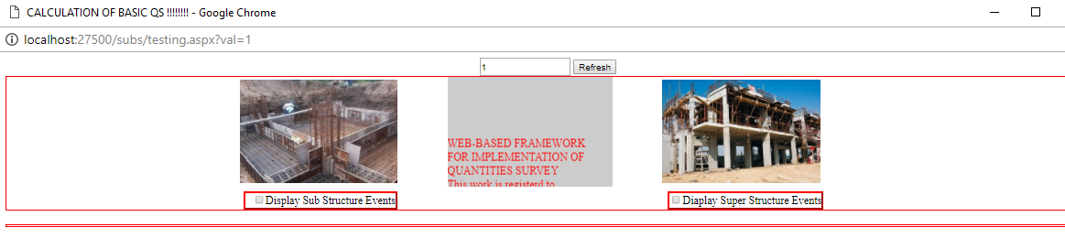

**Figure 4.8** QS Sub and Super structure categories

When the user click the “Display Sub Structure Events “ check box or the image above the checkbox , new screen described in figure 4.8 appears to demonstrate all sub structure operations related to the QS, the as we can noted that the project number is attached with all screen to make sure that the system will save and update the information to the correct table .

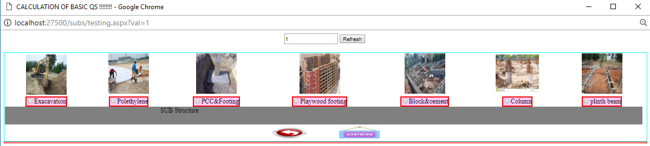

**Figure 4.9** Sub structure operation screen

The screen work as a sub hub to manage the QS workflow of sub structure operations starting from Excavation, Polyethylene ,PCC etc.… up to the plinth beam tasks .

When the user click the Excavation checkbox ,figure 4.9 appears to allow the user to update the Excavation information related to the selected project .

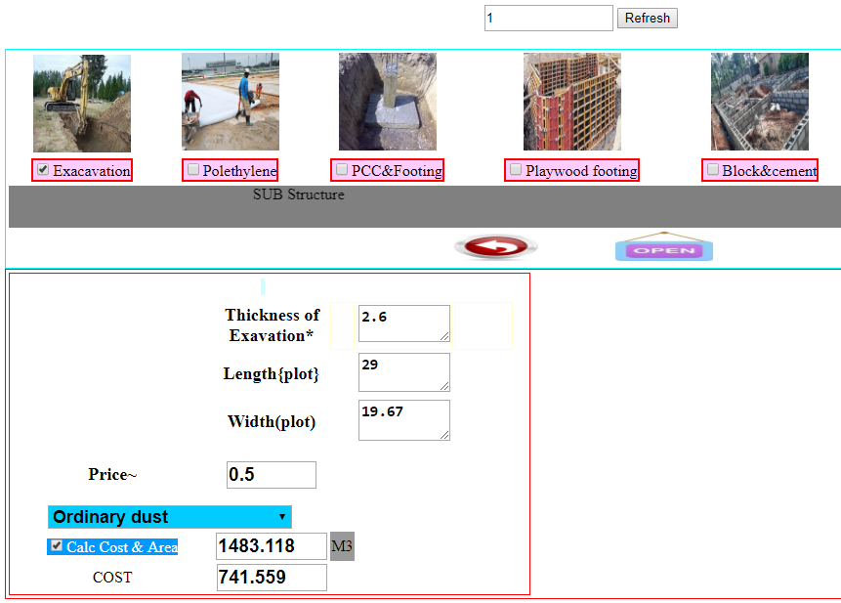

**Figure 4.10** QS Excavation information Form

When the user click the “calc cost and area “check box the system is expected to update the information to the related table as well as the system will notify the user with pop up message about the status of the operation as shown in figure 4.10 .

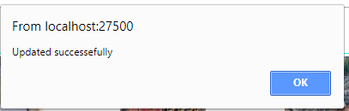

**Figure 4.11** user massage after any CRUD operation

When the user click the “Polethlene” checkbox , figure 4.11 appears to allow the user to update the QS Polyethylene tasks .

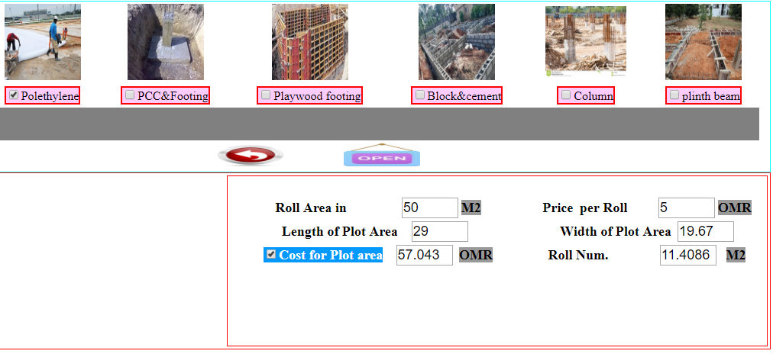

**Figure 4.12** QSPolyethylene

When the user click the PCC & Footing checkbox, Figure 4.12 appears to allow the user to enter the PCC Data obtained from the building consult company , after what the user in one click could obtained the Pcc Information as shown in figure 4.13 i.e. the volume of the Pcc ,Footing Steel , Footing concrete and the footing Binding wires

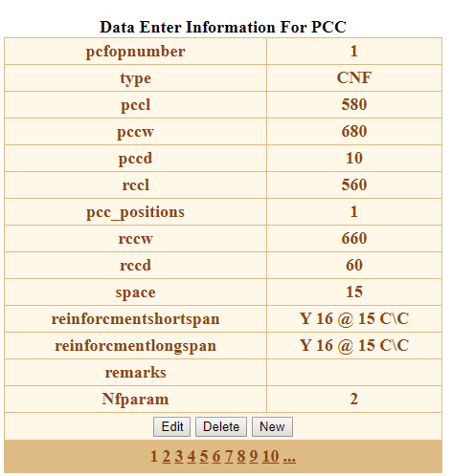

**Figure 4.13** Footing data entry form

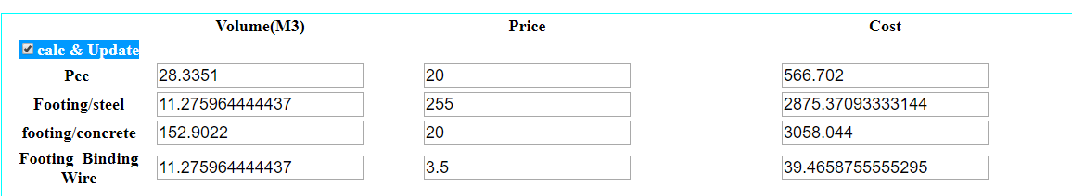

**Figure 4.14** footing information update screen

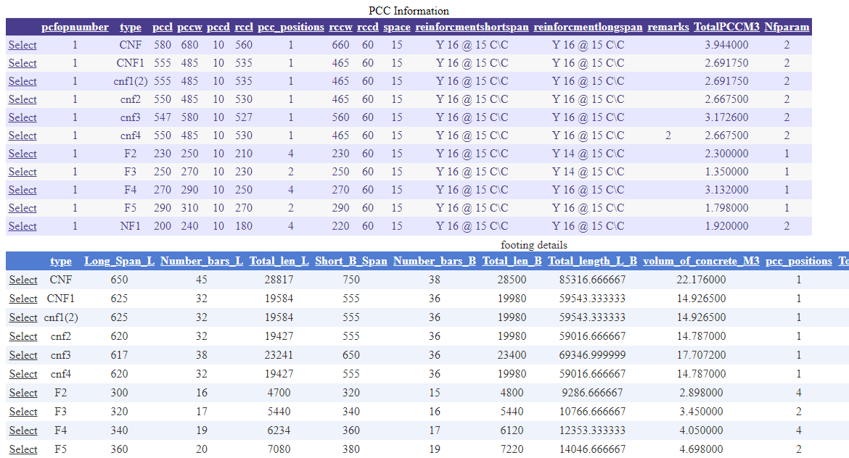

**Figure 4.15** Details of Concrete Footing calculation screen

The Details of Concrete Footing calculation screen allow the user to capture the concrete calculationdetails.

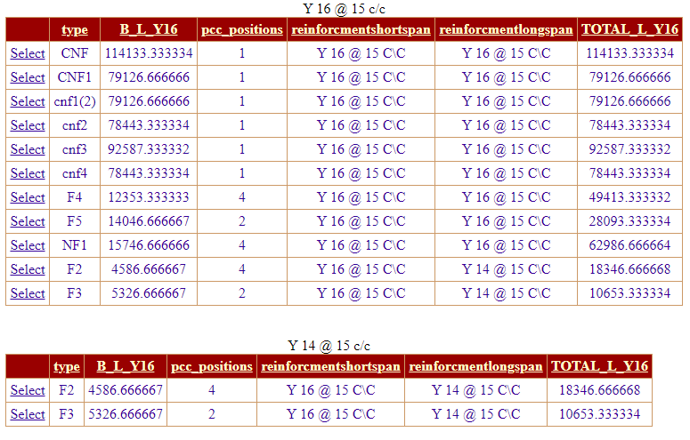

**Figure 4.16** Details of Steel Footing calculation screen

The Details of Steel Footing calculation screen allow the user to capture the steel calculation details of the footing phase .

“The information appears in figure 4.13 1nd figure 4.14 are generated automatically during data entry without the user intervention.”

“When the user click the plywood footing checkbox , Figure 4.15 appears , the information also generated automatically without the user intervention , based on the data that have been pass in as described in figure 4.11 .”

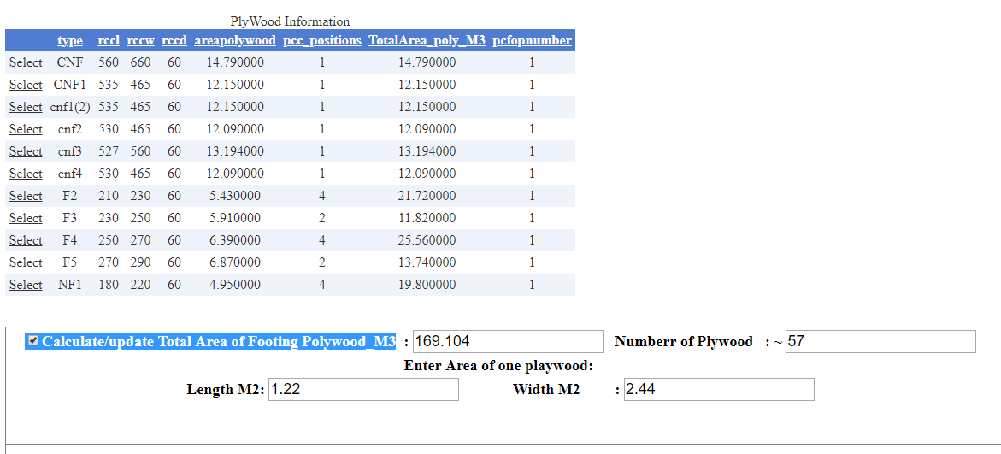

**Figure 4.17**Plywood footing information

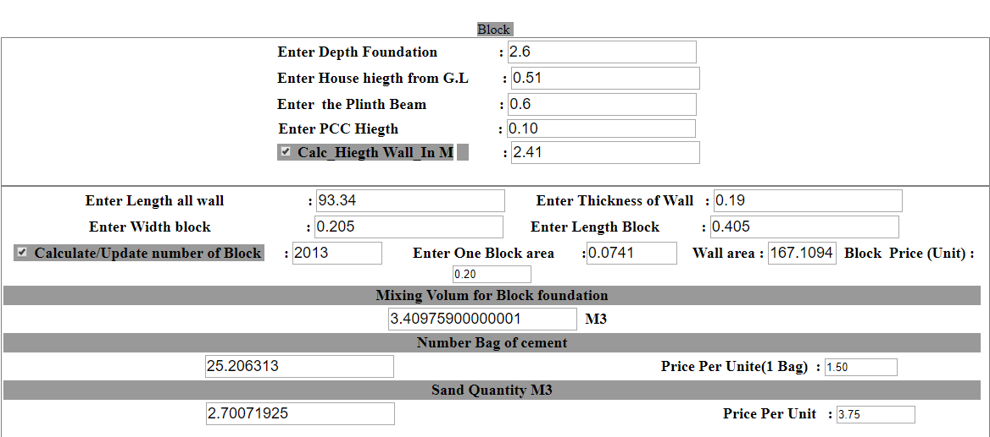

**Figure 4.18** Block Information screen

“The Block Information screen also generated based on the project data set.

The screen coming on when the user click the checkbox control.”

“Column Operation:

When the user click the column checkbox, Figures 4.17 ,4.18,4.19 appears to demonstrate the data entry of column and all other related task.”

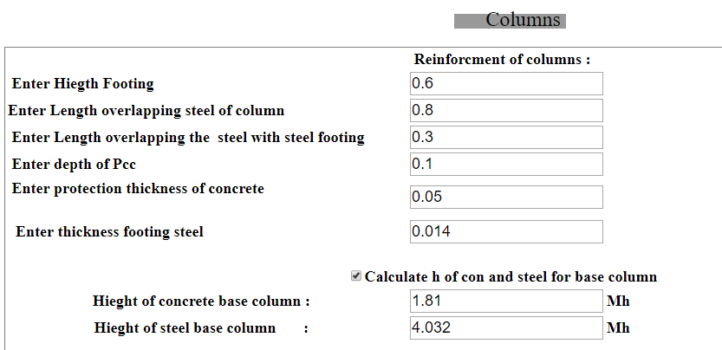

**Figures 4.19**

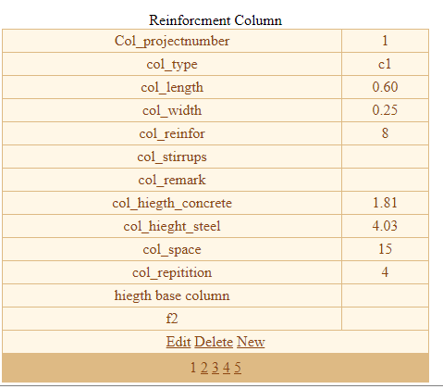

**Figure 4.20**

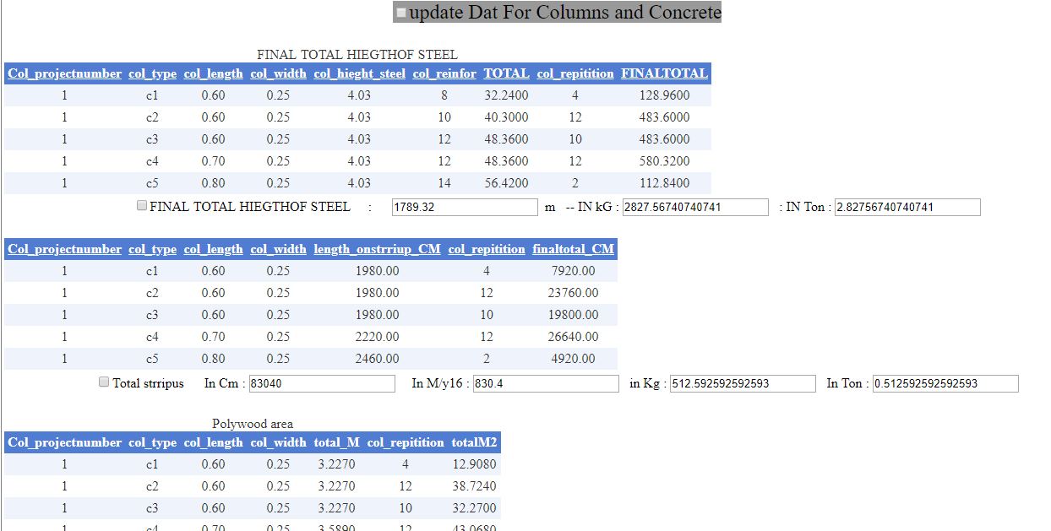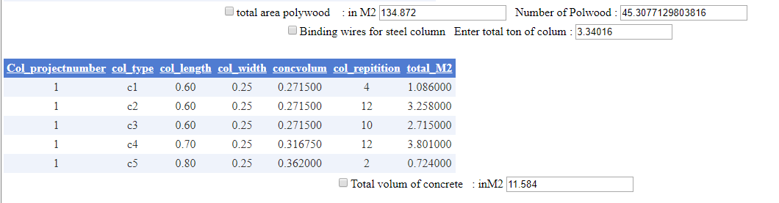

**Figure 4.21**

“Figure 4.21shows the Plainth Beam operations “.

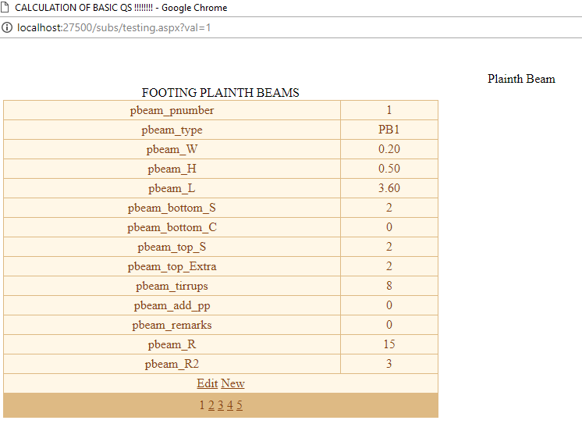

**Figure 4.21** Plainth data entry form

“Figure 4.21 demonstrate the calculation details of the plainth beams operation , which is in fact generated automatically by the system considering the data that have been entered in figure 4.20”

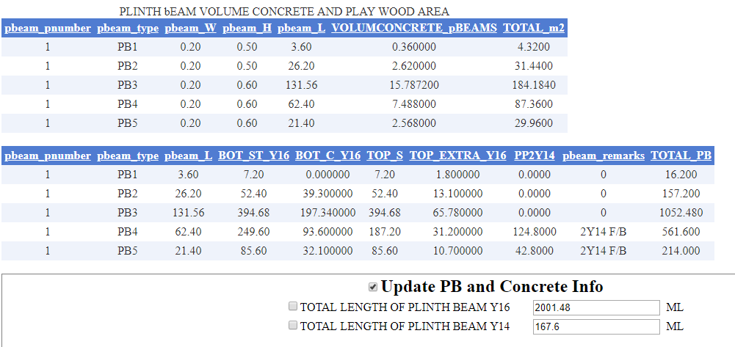

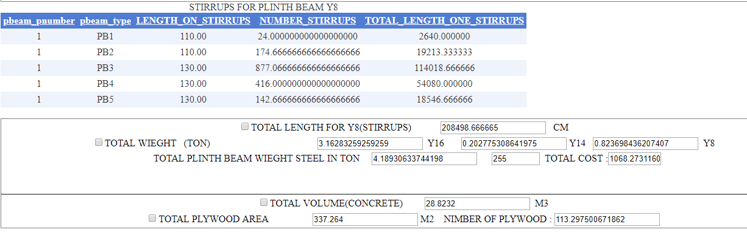

Super Structure

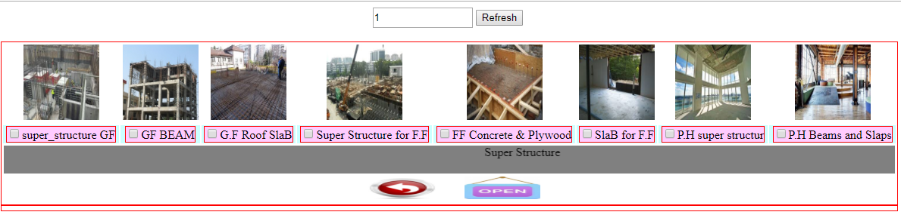

**Figure 4.22** Main window screen for super structure tasks

The Main window screen for super structure tasks allow the user to discover the various operations related to the super structure tasks , Therefore when the user click the “ super_structure GF” CheckBox ,the “GF” stands for Grand Floor ,figure 4.23 demonstrate the contents of this screen .

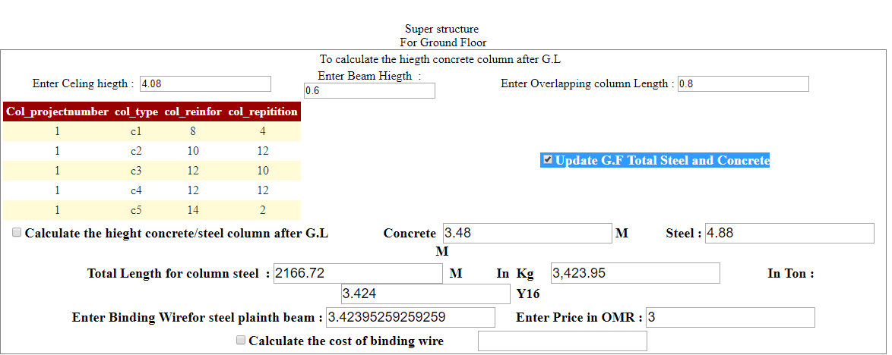

**Figure 4.23** GF Steel and Concreate calculation screen

In one click the user will obtain the Total length of required column steel volume as well as for the required concrete needs for the ground floor (GF). And the system will also calculate the same for the Stirrups steel ,concrete and plywood , figure 4.24 shows the details of the calculation .

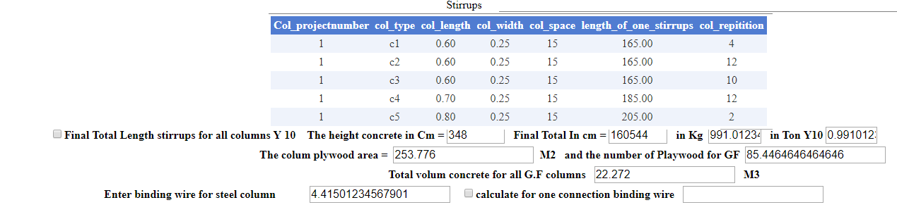

**Figure 4.24** Stirrups calculation screen

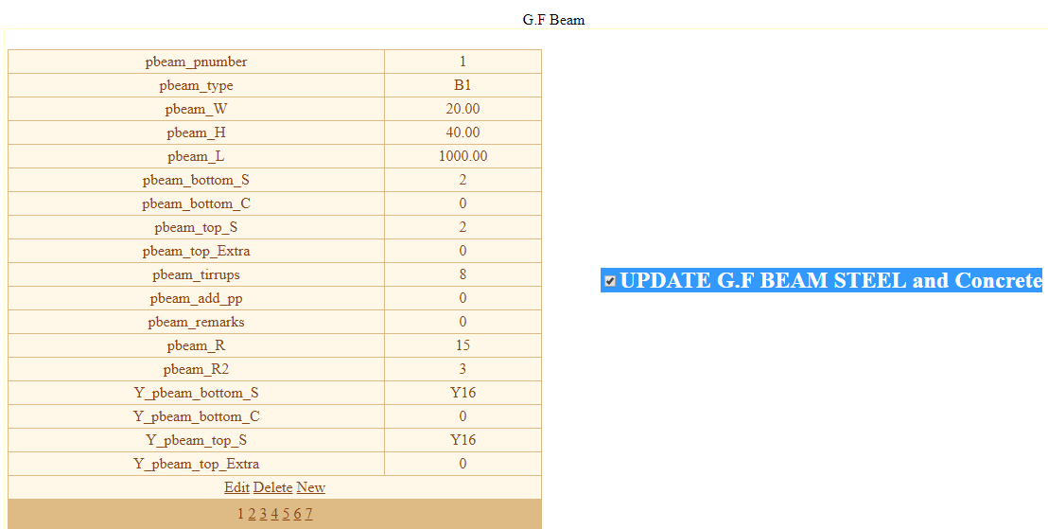

**Figure 4.25** Grand Floor Beams screen

The Grand Floor Beams screen allow the user to enter the data about the Ground floor beams which in fact proposed by the consultant company , in addition to that the screen allow also the user to perform the CRUD Database operations . Figure 4.25 and 4.26 demonstrated the generated screens for more details related to the results.

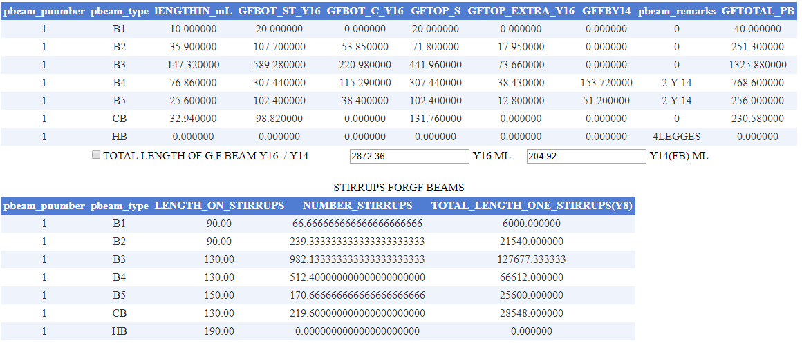

**Figure 4.26** Details screen for GF Beams calculations

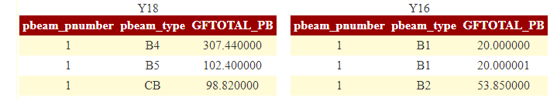

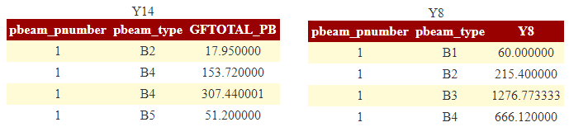



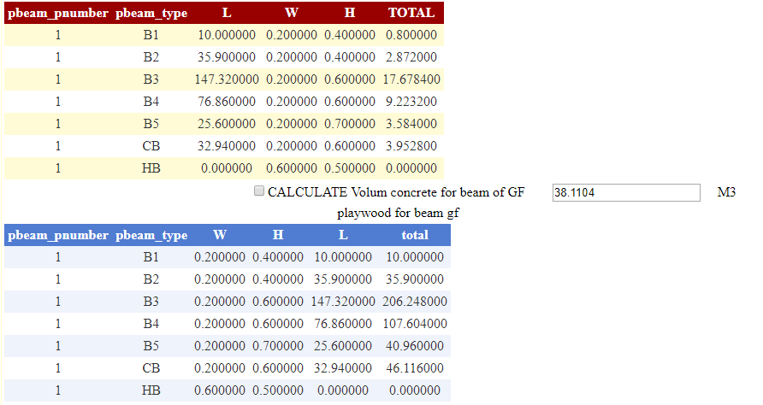

**Figure 4.27** Details screen for GF Plywood Beams calculations

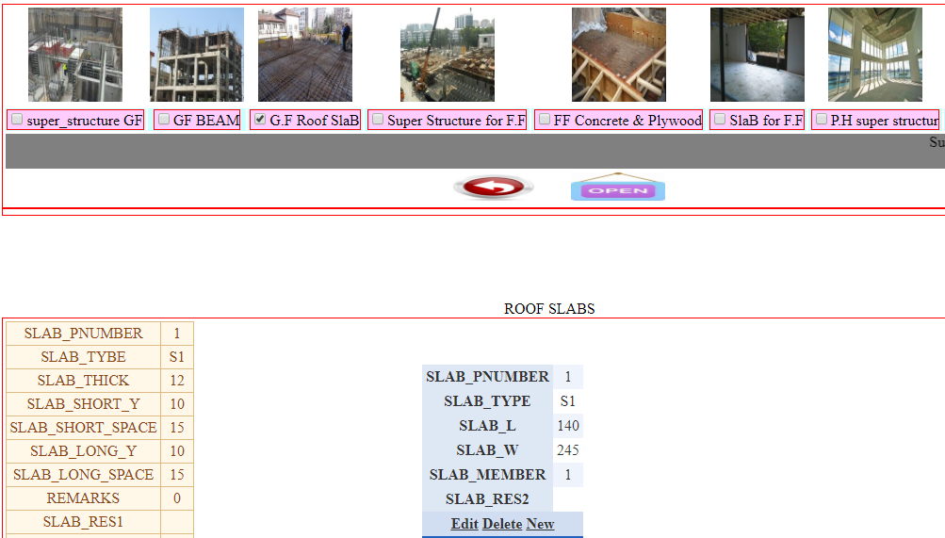

**Figure 4.28** Roof Slabs Screen Data Entry

The Roof Slabs Screen Data Entry allow the user to perform CRUD operation related to the Slab Tasks .

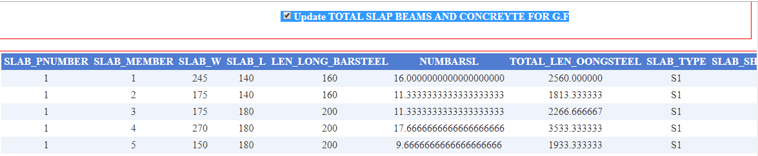

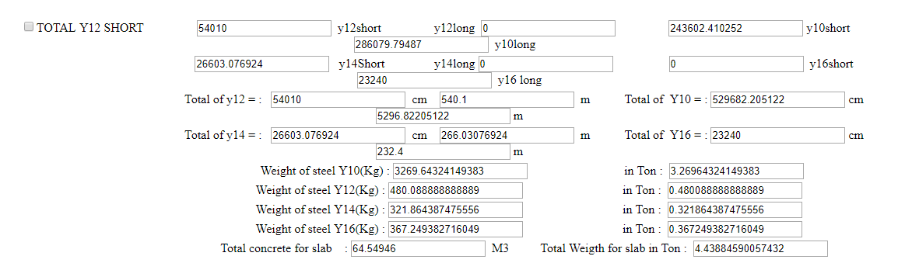

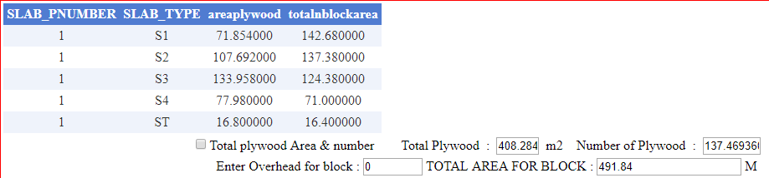

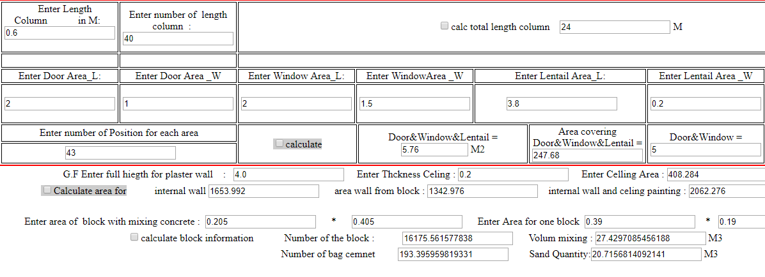

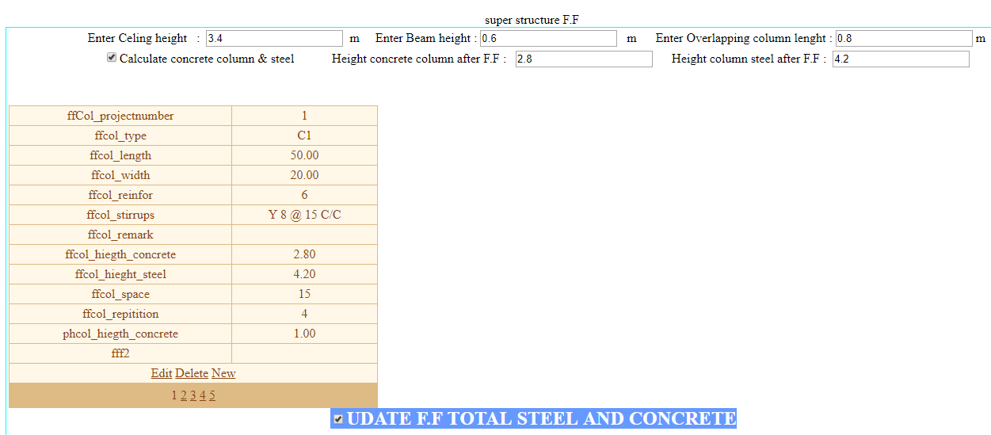

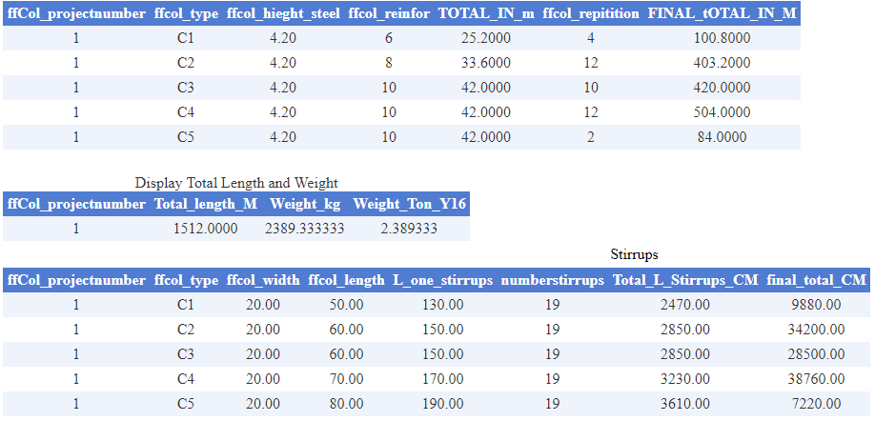

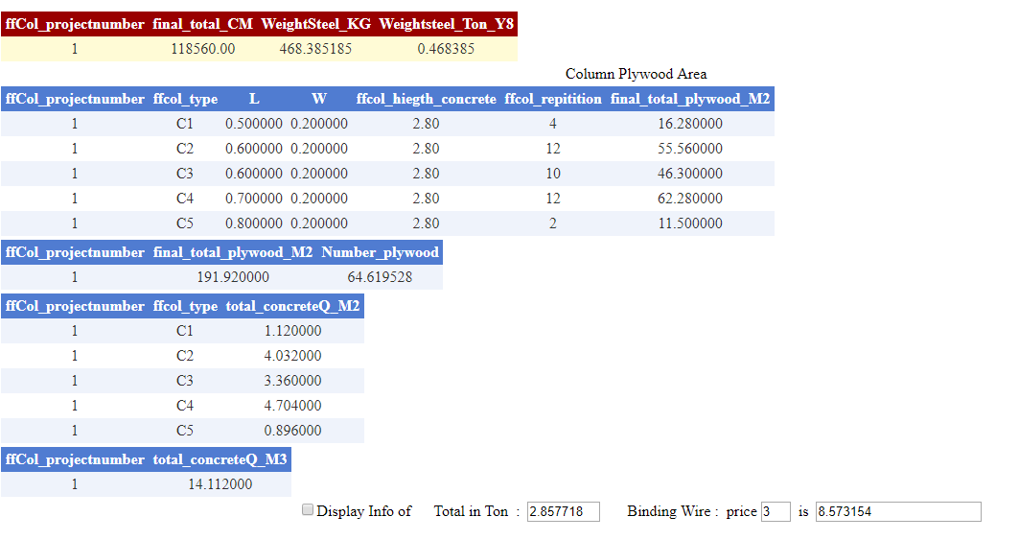

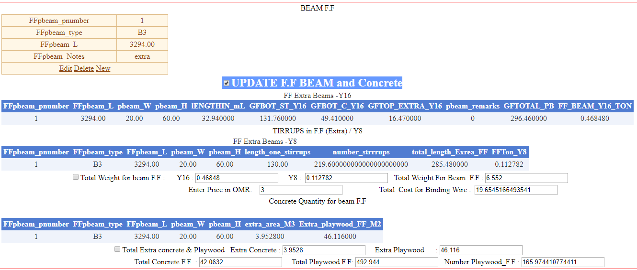

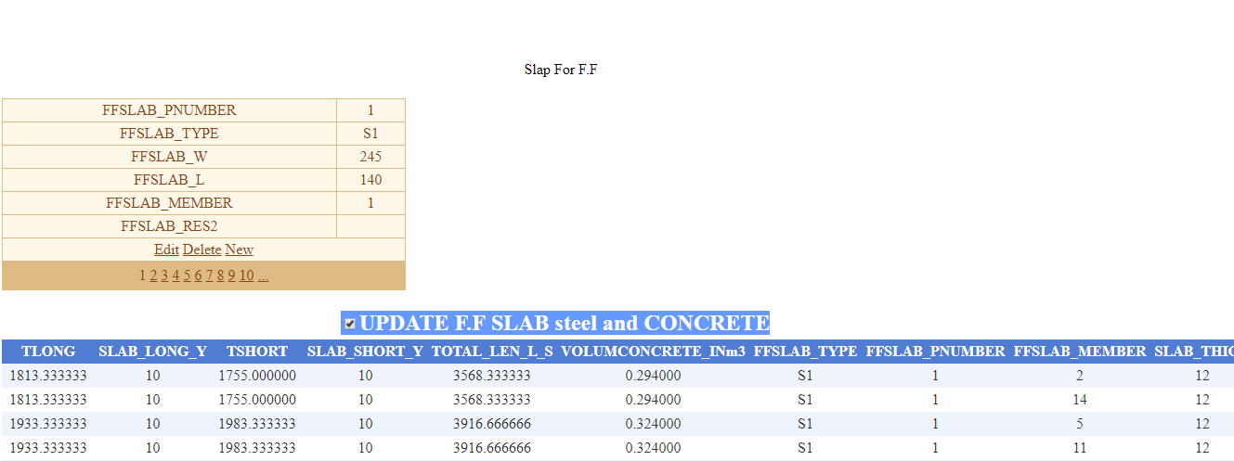

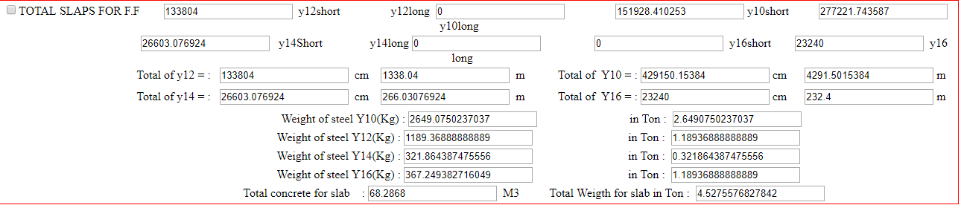

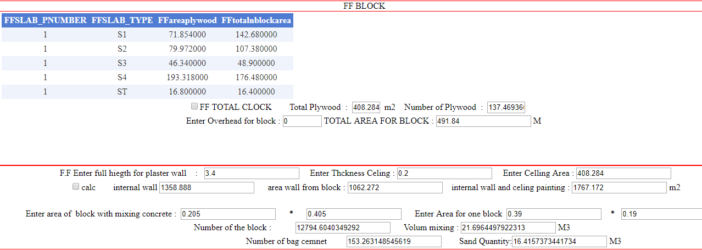

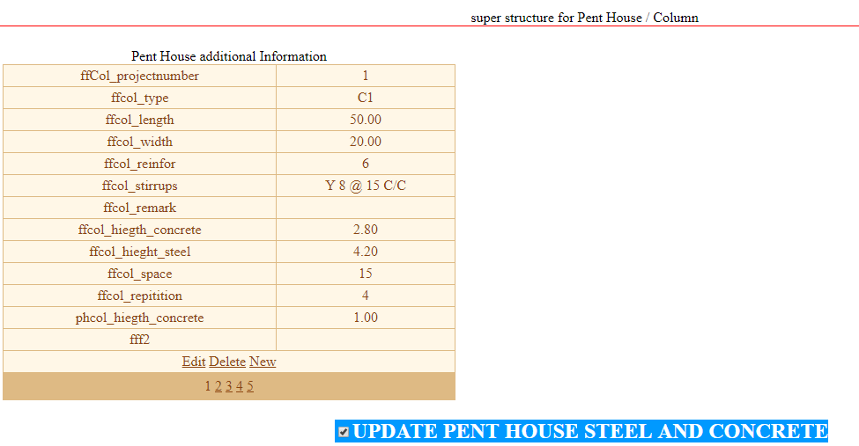

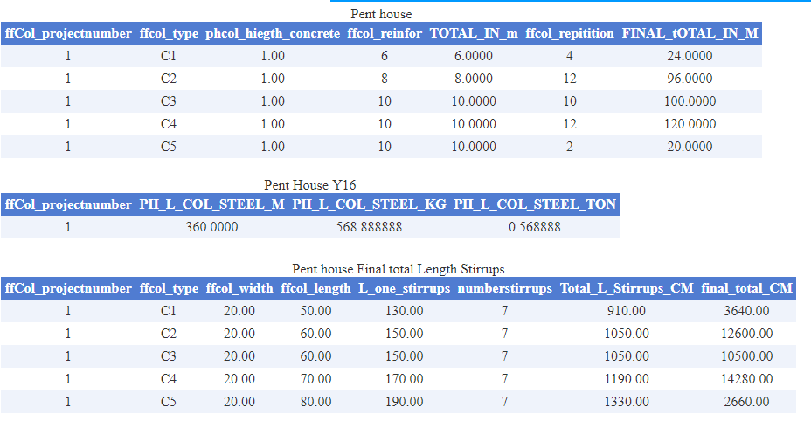

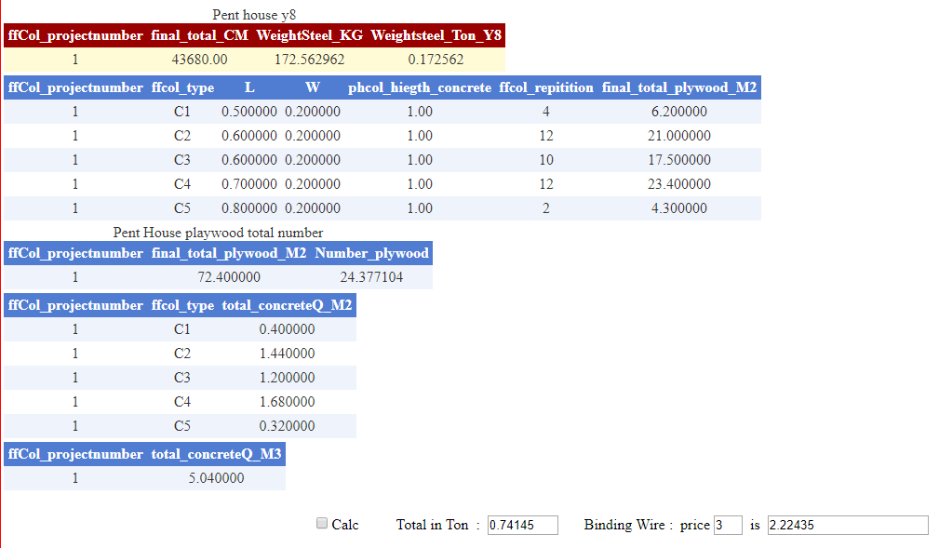

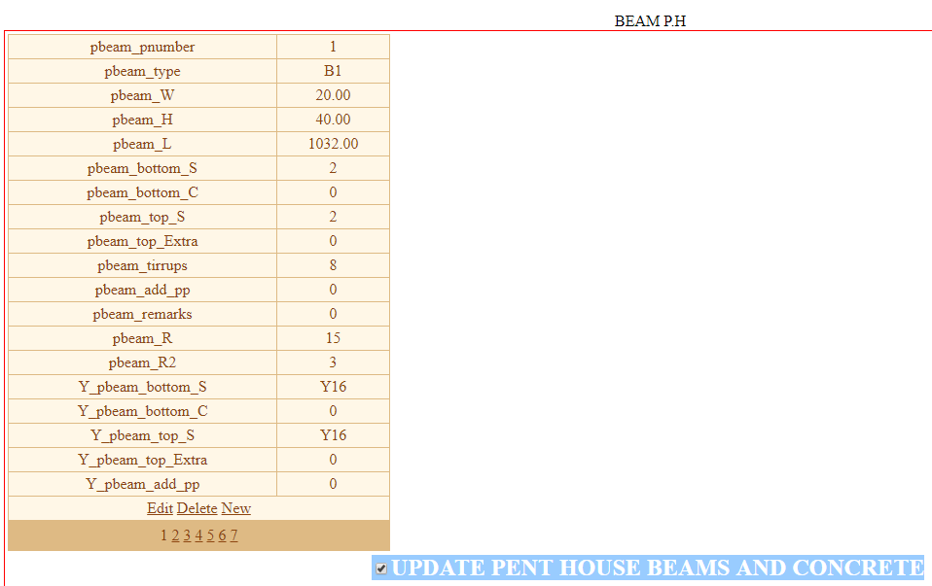

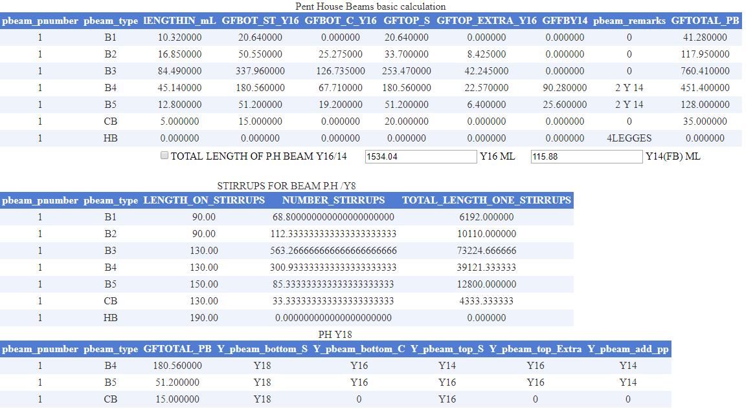

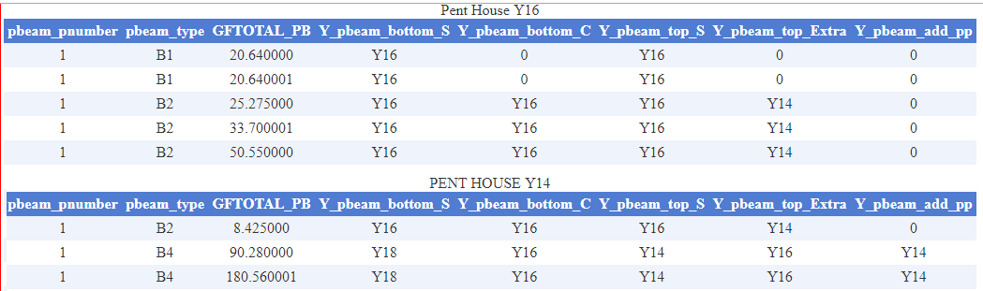

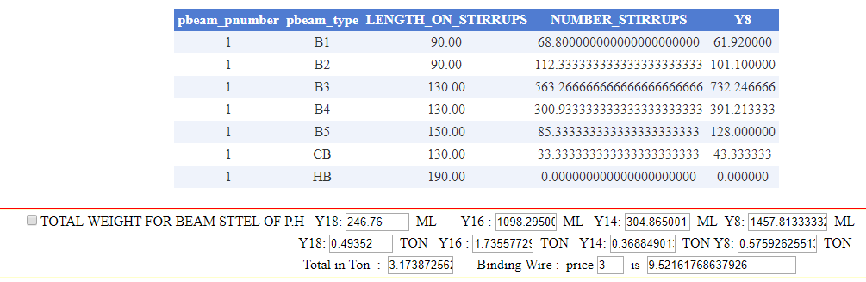

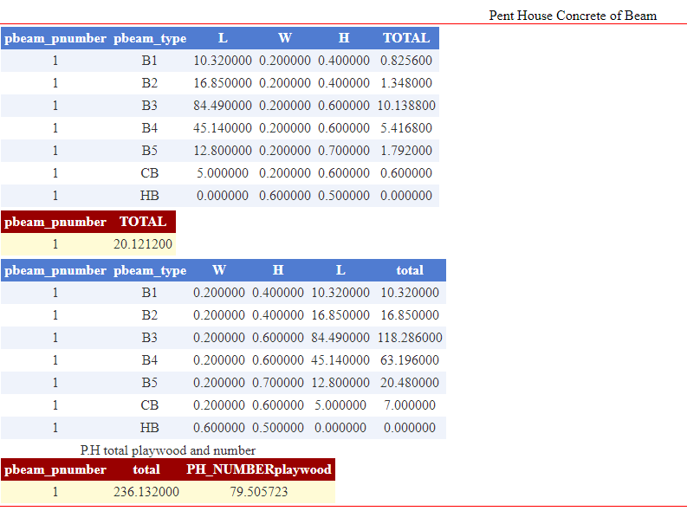

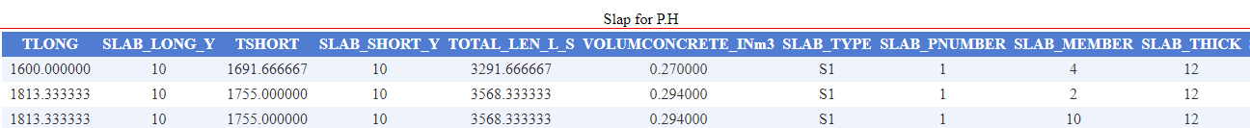

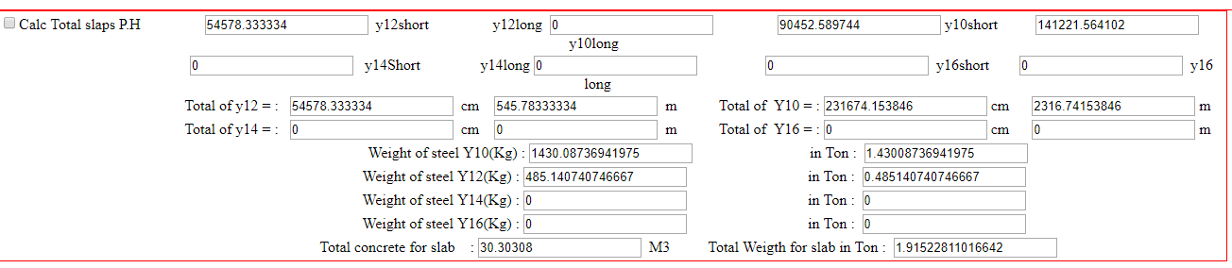

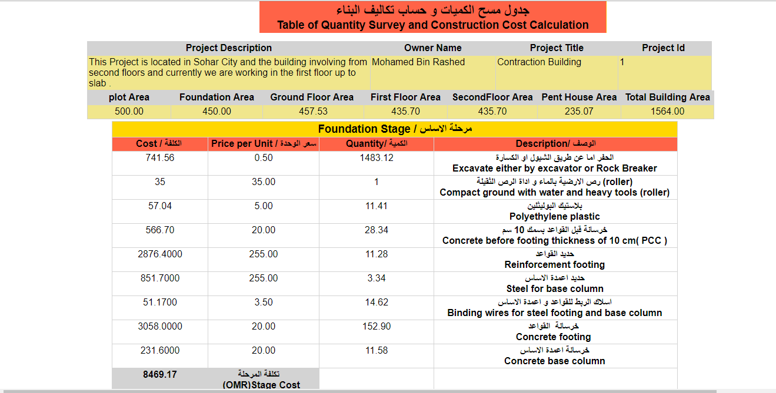

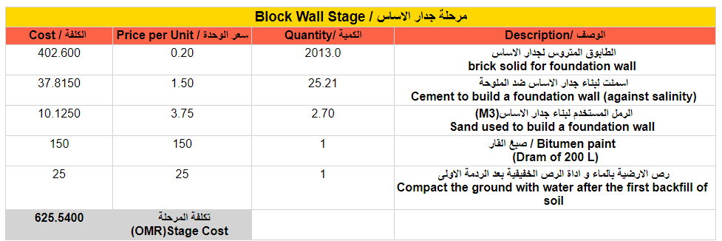

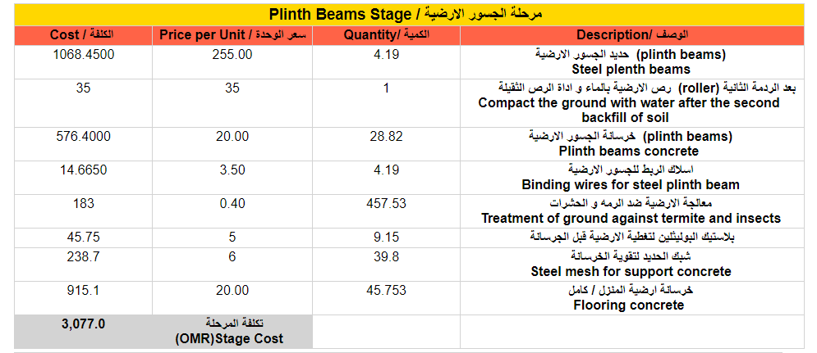

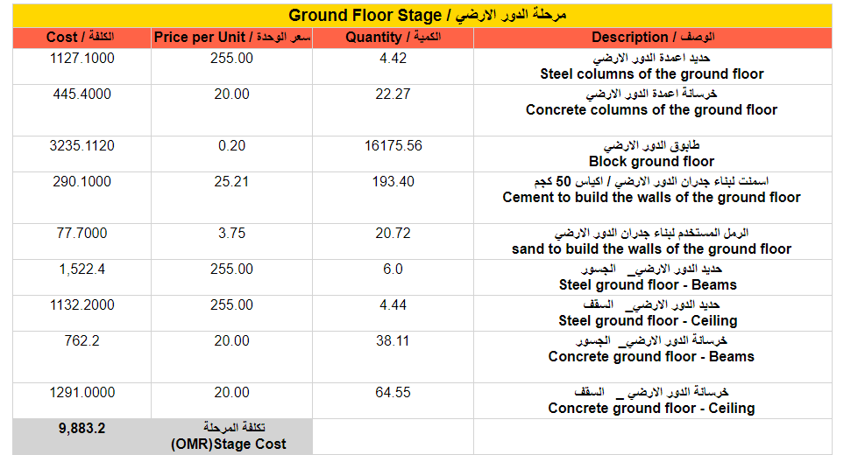

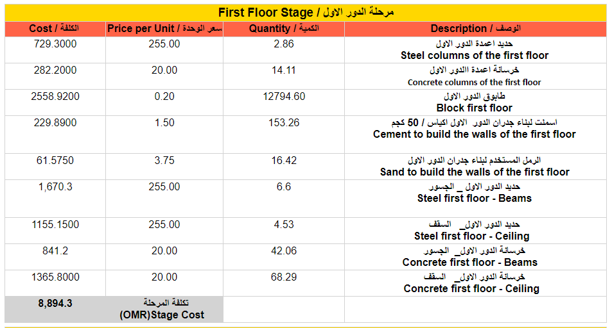

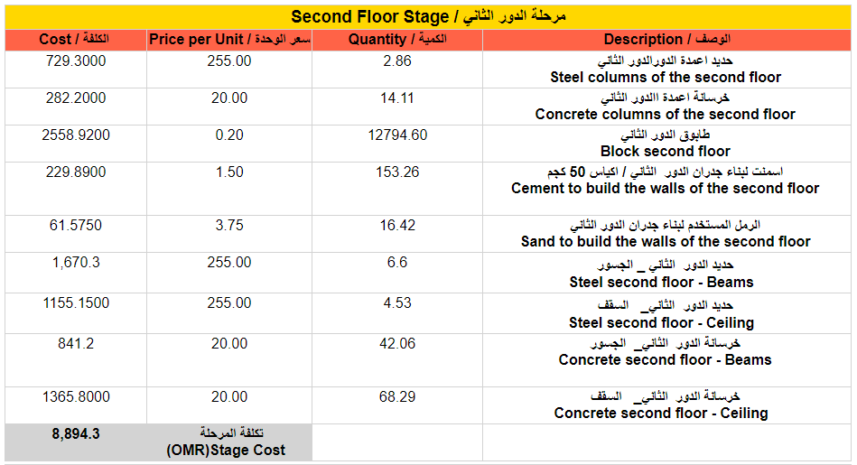

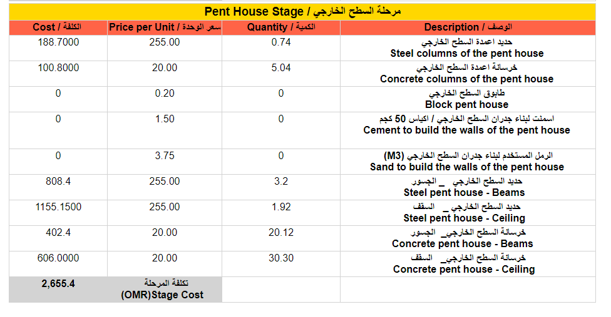

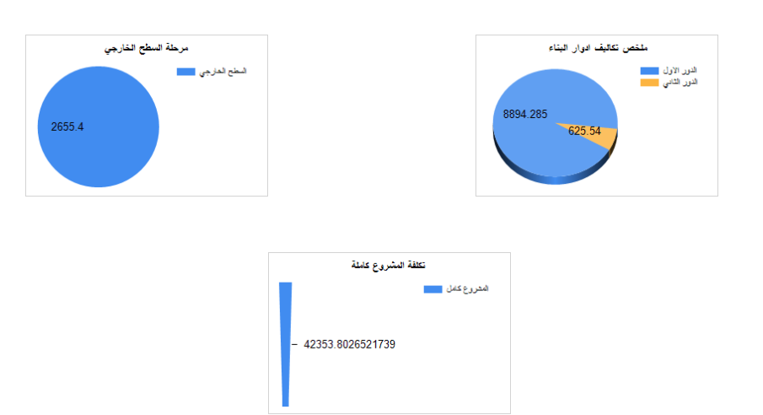

**APPENDIX B**

**Sample Source Code**

using System;

usingSystem.Collections.Generic;

usingSystem.Linq;

usingSystem.Web;

usingSystem.Web.UI;

usingSystem.Web.UI.WebControls;

usingSystem.Data.SqlClient;

using System.IO;

public partial class subs_testing : System.Web.UI.Page

{

//SqlConnectioncn = new SqlConnection(@"Data Source = (LocalDB)\MSSQLLocalDB;AttachDbFilename=|DataDirectory|\building.mdf;Integrated Security = True");

// connectionString="Server=(LocalDB)\v11.0;Initial File Name=|DataDirectory|\DatabaseFileName.mdf;Database=DatabaseName;Trusted_Connection=True;MultipleActiveResultSets=True"

SqlConnectioncn = new SqlConnection(@"Data Source = (LocalDB)\MSSQLLocalDB;Initial File Name=|DataDirectory|\building.mdf;Trusted_Connection=True;MultipleActiveResultSets=True");

protected void Page_Load(object sender, EventArgs e)

{

try

{

stringpt = Request.QueryString["val"];

TextBox1.Text = pt.ToString();

}

catch

{

Response.Redirect("basicareas.aspx");

}

}

protected void DetailsView1_ItemInserted(object sender, DetailsViewInsertedEventArgs e)

{

try

{

}

catch

{ erromsg(); }

}

protected void DetailsView1_PreRender(object sender, EventArgs e)

{

GridView2.DataBind();

GridView3.DataBind();

GridView4.DataBind();

GridView1.DataBind();

//ScriptManager.RegisterClientScriptBlock(this, this.GetType(), "alertMessage", "alert('Thank you ,updayed successfully ')", true);

//TextBox1.Text = "1";

//DetailsView1.Rows[0].Cells[1].Text = TextBox1.Text;

}

protected void Button1_Click(object sender, EventArgs e)

{

cn.Open();

stringsql = "update [table] set pcfopnumber='" + TextBox1.Text + "' where pcfopnumber IS NULL ";

SqlCommandcmd = new SqlCommand(sql, cn);

cmd.ExecuteNonQuery();

cn.Close();

GridView2.DataBind();

GridView3.DataBind();

GridView4.DataBind();

GridView1.DataBind();

}

try

{

cn.Open();

string sql4 = "UPDATE first_QS SET projectid='" + TextBox1.Text + "', Polthylene_volume='" + TextBox20.Text + "',Polthylene_price='" + TextBox9.Text + "',Polthylene_cost='" + TextBox19.Text + "' where projectid ='" + TextBox1.Text + "'";

SqlCommandcmd = new SqlCommand(sql4, cn);

cmd.ExecuteNonQuery();

successomsg();

cn.Close();

}

catch

{

erromsg();

}

}

protected void updatpcc()

{

try

{

cn.Open();

string sql4 = "UPDATE first_QS SET pcc_B_W_C ='" + TextBox37.Text + "' ,pcc_B_W_V ='" + TextBox294.Text + "',pcc_B_W_P ='" + TextBox295.Text + "', projectid='" + TextBox1.Text + "' , footing_steel_re_ton='" + TextBox29.Text + "',footing_steel_re_ton_price='" + TextBox30.Text + "',footing_steel_re_ton_cost='" + TextBox31.Text + "' , footing_concrete_volume='" + TextBox32.Text + "',footing_concrete_price='" + TextBox33.Text + "',footing_concrete_cost='" + TextBox34.Text + "' , pcc_volume='" + TextBox35.Text + "',pcc_price='" + TextBox27.Text + "',pcc_cost='" + TextBox28.Text + "' where projectid ='" + TextBox1.Text + "'";

SqlCommandcmd = new SqlCommand(sql4, cn);

cmd.ExecuteNonQuery();

successomsg();

cn.Close();

}

catch

{

////erromsg();

}

}

protected void footingupdatplywood()

{

try

{

cn.Open();

string sql4 = "UPDATE first_QS SET foo_pw_area ='" + TextBox40.Text + "' ,foo_pw_num ='" + TextBox41.Text + "' Where projectid ='" + TextBox1.Text + "'";

SqlCommandcmd = new SqlCommand(sql4, cn);

cmd.ExecuteNonQuery();

successomsg();

cn.Close();

}

catch

{

erromsg();

}

}

protected void plwoodnum()

{

double sum16 = 0;

for (int i = 0; i < GridView7.Rows.Count; i++)

{

double elm = Convert.ToDouble(GridView7.Rows[i].Cells[7].Text);

sum16 = sum16 + elm;

}

{

erromsg();

}

try

{

cn.Open();

string sql4 = "UPDATE first_QS SET FOO_BL_N ='" + TextBox53.Text + "' ,FOO_BL_N_Price ='" + TextBox296.Text + "' ,FOO_MBL_V ='" + TextBox56.Text + "',FOO_BL_Sand_V ='" + TextBox58.Text + "',FOO_BL_Sand_price ='" + TextBox298.Text + "', FOO_BL_Bag_Cem_N ='" + TextBox57.Text + "', FOO_BL_Bag_Cem_Price ='" + TextBox297.Text + "' Where projectid ='" + TextBox1.Text + "'";

SqlCommandcmd = new SqlCommand(sql4, cn);

cmd.ExecuteNonQuery();

successomsg();

cn.Close();

}

catch

{

erromsg();

}

}

}

protected void CheckBox19_CheckedChanged(object sender, EventArgs e)

{

try

{

foot_Colum_Y16();

Foot_Colum_stirrups();

FOOT_COL_PLWOOD();

FOOT_COL_BINDINGWIRE();

FOOT_COL_CONCTER();

foot_COLU_UPDATE();

}

catch

{

erromsg();

}

protected void CheckBox21_CheckedChanged(object sender, EventArgs e)

{

Foot_Colum_stirrups();

}

protected void Foot_Colum_stirrups()

{

double sum16 = 0;

for (int i = 0; i < GridView9.Rows.Count; i++)

{

double elm = Convert.ToDouble(GridView9.Rows[i].Cells[6].Text);

sum16 = sum16 + elm;

}

TextBox70.Text = sum16.ToString();

double mm = sum16 / 100;

TextBox71.Text = mm.ToString();

double kg = 10 * 10 * mm / 162;

TextBox72.Text = kg.ToString();

double ton = kg / 1000;

TextBox73.Text = ton.ToString();

double ton3 = Convert.ToDouble(TextBox69.Text);

TextBox76.Text = (ton + ton3).ToString();

}

protected void CheckBox22_CheckedChanged(object sender, EventArgs e)

{

FOOT_COL_PLWOOD();

}

protected void FOOT_COL_PLWOOD()

{

double sum16 = 0;

for (int i = 0; i < GridView10.Rows.Count; i++)

{

double elm = Convert.ToDouble(GridView10.Rows[i].Cells[6].Text);

sum16 = sum16 + elm;

}

TextBox74.Text = sum16.ToString();

double l = Convert.ToDouble(TextBox38.Text);

double w = Convert.ToDouble(TextBox39.Text);

doublenumpol = sum16 / (l * w);

TextBox75.Text = numpol.ToString();

}

protected void CheckBox23_CheckedChanged(object sender, EventArgs e)

{

FOOT_COL_BINDINGWIRE();

}

protected void FOOT_COL_BINDINGWIRE()

{

double tony16 = Convert.ToDouble(TextBox69.Text);

doubletonstr = Convert.ToDouble(TextBox73.Text);

double total = tony16 + tonstr;

TextBox76.Text = total.ToString();

}

protected void CheckBox24_CheckedChanged(object sender, EventArgs e)

{

FOOT_COL_CONCTER();

}

protected void FOOT_COL_CONCTER()

{

double sum16 = 0;

for (int i = 0; i < GridView11.Rows.Count; i++)

{

double elm = Convert.ToDouble(GridView11.Rows[i].Cells[6].Text);

sum16 = sum16 + elm;

}

TextBox79.Text = sum16.ToString();

}

protected void CheckBox25_CheckedChanged(object sender, EventArgs e)

{

Panel8.Visible = CheckBox25.Checked;

}

protected void CheckBox26_CheckedChanged(object sender, EventArgs e)

{

FOOT_PLAINTHBEAM_CONCRETE();

}

protected void FOOT_PLAINTHBEAM_CONCRETE()

{

double sum16 = 0;

for (int i = 0; i < GridView12.Rows.Count; i++)

{

double elm = Convert.ToDouble(GridView12.Rows[i].Cells[5].Text);

sum16 = sum16 + elm;

}

TextBox80.Text = sum16.ToString();

}

protected void CheckBox27_CheckedChanged(object sender, EventArgs e)

{

FOOT_PLYWOOD_PLATHBEAM();

}

protected void FOOT_PLYWOOD_PLATHBEAM()

{

double l = Convert.ToDouble(TextBox38.Text);//PLYWOOD L

double w = Convert.ToDouble(TextBox39.Text);//PLYWOOD W

double sum16 = 0;

for (int i = 0; i < GridView12.Rows.Count; i++)

{

double elm = Convert.ToDouble(GridView12.Rows[i].Cells[6].Text);

sum16 = sum16 + elm;

}

TextBox81.Text = sum16.ToString();

double NUM = sum16 / (l * w);

TextBox82.Text = NUM.ToString();

}

protected void CheckBox28_CheckedChanged(object sender, EventArgs e)

{

foot_PB_Y16Y14();

}

protected void foot_PB_Y16Y14()

{

double sum16 = 0;

for (int i = 0; i < GridView13.Rows.Count; i++)

{

double elm = Convert.ToDouble(GridView13.Rows[i].Cells[9].Text);

sum16 = sum16 + elm;

}

TextBox83.Text = sum16.ToString();

double sum14 = 0;

for (int i = 0; i < GridView13.Rows.Count; i++)

{

double elm = Convert.ToDouble(GridView13.Rows[i].Cells[7].Text);

sum14 = sum14 + elm;

}

TextBox84.Text = sum14.ToString();

}

protected void CheckBox29_CheckedChanged(object sender, EventArgs e)

{

double sum16 = 0;

for (int i = 0; i < GridView13.Rows.Count; i++)

{

double elm = Convert.ToDouble(GridView13.Rows[i].Cells[7].Text);

sum16 = sum16 + elm;

}

TextBox84.Text = sum16.ToString();

}

protected void CheckBox30_CheckedChanged(object sender, EventArgs e)

{

foot_PB_Y8();

}

protected void foot_PB_Y8()

{

double sum16 = 0;

for (int i = 0; i < GridView14.Rows.Count; i++)

{

double elm = Convert.ToDouble(GridView14.Rows[i].Cells[4].Text);

sum16 = sum16 + elm;

}

TextBox85.Text = sum16.ToString();

}

protected void CheckBox31_CheckedChanged(object sender, EventArgs e)

{

foot_PB_TOTALTON();

}

protected void foot_PB_TOTALTON()

{

double y16 = Convert.ToDouble(TextBox83.Text);

double y14 = Convert.ToDouble(TextBox84.Text);

double y8 = Convert.ToDouble(TextBox85.Text) / 100;

y16 = ((16 * 16) * y16 / 162) / 1000;

TextBox86.Text = y16.ToString();

y14 = ((14 * 14) * y14 / 162) / 1000;

TextBox87.Text = y14.ToString();

y8 = ((8 * 8) * y8 / 162) / 1000;

TextBox88.Text = y8.ToString();

double TOTALTON = y16 + y14 + y8;

TextBox89.Text = TOTALTON.ToString();

double PRICE = Convert.ToDouble(TextBox90.Text);

TextBox91.Text = (TOTALTON * PRICE).ToString();

}

protected void CheckBox32_CheckedChanged(object sender, EventArgs e)

{

Panel9.Visible = CheckBox32.Checked;

}

protected void CheckBox33_CheckedChanged(object sender, EventArgs e)

{

GF_STEELCON();

}

protected void GF_STEELCON()

{

doublech = Convert.ToDouble(TextBox92.Text); //celinghiegth

doublebh = Convert.ToDouble(TextBox93.Text); // beam hiegth

double overlapping = Convert.ToDouble(TextBox95.Text); // overlapping col length

double total = ch - bh;

TextBox94.Text = total.ToString();

doublecolsteel = ch + overlapping; //hiegh steel column

TextBox96.Text = colsteel.ToString();

doublesumsteel = 0;

for (int i = 0; i < GridView15.Rows.Count; i++)

{

double elm1 = Convert.ToDouble(GridView15.Rows[i].Cells[2].Text);

double elm2 = Convert.ToDouble(GridView15.Rows[i].Cells[3].Text);

double results = colsteel * elm1 * elm2;

sumsteel = sumsteel + results;

}

TextBox100.Text = sumsteel.ToString();

doublesteelkg = (16 * 16 * sumsteel) / 162;

TextBox101.Text = steelkg.ToString("N2");

doublesteelton = steelkg / 1000;

TextBox102.Text = steelton.ToString("N3");

TextBox97.Text = steelton.ToString();

}

if (Y12long == "16")

{

double elm = Convert.ToDouble(GridView60.Rows[i].Cells[0].Text);

y16long = y16long + elm;

}

// y12

if (Y12SHORT == "12")

{

double elm = Convert.ToDouble(GridView60.Rows[i].Cells[2].Text);

y12sh = y12sh + elm;

}

if (Y12long == "12")

{

double elm = Convert.ToDouble(GridView60.Rows[i].Cells[0].Text);

y12long = y12long + elm;

}

if (Y12SHORT == "10")

{

double elm = Convert.ToDouble(GridView60.Rows[i].Cells[2].Text);

y10sh = y10sh + elm;

}

if (Y12long == "10")

{

double elm = Convert.ToDouble(GridView60.Rows[i].Cells[0].Text);

y10long = y10long + elm;

}

}

// y14 y 16

TextBox272.Text = y14sh.ToString();

TextBox273.Text = y14long.ToString();

TextBox274.Text = y16sh.ToString();

TextBox275.Text = y16long.ToString();

double y14 = y14sh + y14long;

double y16 = y16sh + y16long;

TextBox280.Text = y14.ToString();

TextBox281.Text = (y14 / 100).ToString();

TextBox282.Text = y16.ToString();

TextBox283.Text = (y16 / 100).ToString();

//y10 y12

double y12 = y12sh + y12long;

double y10 = y10sh + y10long;

TextBox268.Text = (y12sh).ToString(); // total y 12

TextBox269.Text = (y12long).ToString(); // total y 12

TextBox276.Text = (y12).ToString(); // total y 12 cm

TextBox277.Text = (y12 / 100).ToString(); // total y 12 m

TextBox270.Text = (y10sh).ToString(); // total y 10

TextBox271.Text = (y10long).ToString(); // total y 10

TextBox278.Text = (y10).ToString(); // total y 10 c

TextBox279.Text = (y10 / 100).ToString(); // total y m

//y10 in kg and ton

double y10gg = (10 * 10 * (y10 / 100)) / 162;

TextBox284.Text = y10gg.ToString();

double y10ton = y10gg / 1000;

TextBox285.Text = y10ton.ToString();

//y12 in kg and ton

double y12gg = (12 * 12 * (y12 / 100)) / 162;

TextBox286.Text = y12gg.ToString();

double y12ton = y12gg / 1000;

TextBox287.Text = y12ton.ToString();

// y 14

//y10 in kg and ton

double y14gg = (14 * 14 * (y14 / 100)) / 162;

TextBox288.Text = y14gg.ToString();

double y14ton = y14gg / 1000;

TextBox289.Text = y14ton.ToString();

//y16

double y16gg = (16 * 16 * (y16 / 100)) / 162;

TextBox290.Text = y16gg.ToString();

double y16ton = y16gg / 1000;

TextBox291.Text = y16ton.ToString();

// wight ton for all

TextBox293.Text = (y10ton + y12ton + y14ton + y16ton).ToString();

//total concrete

doubleconc = 0;

for (int i = 0; i < GridView60.Rows.Count; i++)

{

double elm = Convert.ToDouble(GridView60.Rows[i].Cells[5].Text);

conc = conc + elm;

}

TextBox292.Text = (conc).ToString();

}

protected void CheckBox76_CheckedChanged(object sender, EventArgs e)

{

try

{

GFSLAPS();

GFplaywoodarea();

GFtotalcolumn();

doorwindow();

GFwallarea();

centblock();

UPDAT_GF_SLAB_BEMS();

}

catch

{

erromsg();

}

}

protected void UPDAT_GF_SLAB_BEMS()

{

try

{

cn.Open();

string sql4 = "UPDATE first_QS SET GF_SLAP_BEAMS='" + TextBox153.Text + "', GF_SLAP_CONCRETE= '" + TextBox152.Text + "' ,GF_SLAB_PLWOOD_AREA='" + TextBox154.Text + "' ,GF_SLAB_PLWOOD_NUM='" + TextBox155.Text + "' , GF_BLOCK_NUM = '" + TextBox182.Text + "', GF_MIXING_VOL = '" + TextBox183.Text + "' , GF_BAG_CEMNT = '" + TextBox185.Text + "', GF_SAND_VOL = '" + TextBox186.Text + "' where projectid ='" + TextBox1.Text + "'";

SqlCommandcmd = new SqlCommand(sql4, cn);

cmd.ExecuteNonQuery();

successomsg();

cn.Close();

}

catch

{

erromsg();

}

}

protected void CheckBox51_CheckedChanged(object sender, EventArgs e)

{

try

{

FFSTEELCONC();

updat_FF_TOTALSTEEL();

}

catch

{

erromsg();

}

}

protected void updat_FF_TOTALSTEEL()

{

try

{

cn.Open();

string sql4 = "UPDATE first_QS SET FF_TOTAL_STEEL='" + TextBox194.Text + "', FF_TOTAL_CONCRETE= '" + GridView36.Rows[0].Cells[1].Text + "' ,FF_PLYWOOD_ARE='" + GridView34.Rows[0].Cells[1].Text + "' ,FF_PLYWOOD_NUM='" + GridView34.Rows[0].Cells[2].Text + "' where projectid ='" + TextBox1.Text + "'";

SqlCommandcmd = new SqlCommand(sql4, cn);

cmd.ExecuteNonQuery();

successomsg();

cn.Close();

}

catch

{

erromsg();

}

}

protected void CheckBox77_CheckedChanged(object sender, EventArgs e)

{

try

{

ffbeamweight();

FFconc_plywood();

FF_UPDAT_BEAM();

}

catch

{

erromsg();

}

}

protected void FF_UPDAT_BEAM()

{

try

{

cn.Open();

string sql4 = "UPDATE first_QS SET FF_BEAM='" + TextBox199.Text + "', FF_BEAM_CONCRETE= '" + TextBox202.Text + "' ,FF_BEAM_PLWOOD_AREA='" + TextBox203.Text + "' ,FF_BEAM_PLWOOD_NUM='" + TextBox204.Text + "' where projectid ='" + TextBox1.Text + "'";

SqlCommandcmd = new SqlCommand(sql4, cn);

cmd.ExecuteNonQuery();

successomsg();

cn.Close();

}

catch

{

erromsg();

}

}

protected void CheckBox78_CheckedChanged(object sender, EventArgs e)

{

try

{

FF_total_Slaps();

FFplaywoodarea();

FFblock1();

FFblock2();

UPDAT_FF_SLAP_BEAM();

}

catch

{

erromsg();

}

}

protected void UPDAT_FF_SLAP_BEAM()

{

try

{

cn.Open();

string sql4 = "UPDATE first_QS SET FF_SLAB_BEAMSTEEL='" + TextBox232.Text + "', FF_SLAB_CONCRETE= '" + TextBox231.Text + "' ,FF_SLAP_PLYWOOD_AREA='" + TextBox233.Text + "' ,FF_SLAP_PLYWOOD_NUM='" + TextBox234.Text + "' , FF_SLAB_BLOCK_NUM = '" + TextBox248.Text + "', FF_SLAB_MIXING = '" + TextBox249.Text + "' , FF_SLAB_BAG_CEMNT = '" + TextBox250.Text + "', FF_SLAB_SAND_VOL = '" + TextBox251.Text + "' where projectid ='" + TextBox1.Text + "'";

SqlCommandcmd = new SqlCommand(sql4, cn);

cmd.ExecuteNonQuery();

successomsg();

cn.Close();

}

catch

{

erromsg();

}

}

protected void CheckBox79_CheckedChanged(object sender, EventArgs e)

{

try

{

PH_STEEL();

updat_PH_STEEL();

}

catch

{

erromsg();

}

}

protected void updat_PH_STEEL()

{

try

{

cn.Open();

string sql4 = "UPDATE first_QS SET PH_STEEL='" + TextBox252.Text + "', PH_CONCRETE= '" + GridView49.Rows[0].Cells[1].Text + "' ,PH_PLYWOODAREA='" + GridView47.Rows[0].Cells[1].Text + "' ,PH_PLYWOOD_NUM='" + GridView47.Rows[0].Cells[2].Text + "' where projectid ='" + TextBox1.Text + "'";

SqlCommandcmd = new SqlCommand(sql4, cn);

cmd.ExecuteNonQuery();

successomsg();

cn.Close();

}

catch

{

erromsg();

}

}

protected void CheckBox80_CheckedChanged(object sender, EventArgs e)

{

try

{

PH_BEAM_CM();

total_W_B_PH();

PH_SLAPS();

updat_PH_BEAM_SLAB();

}

catch

{

erromsg();

}

}

protected void updat_PH_BEAM_SLAB()

{

try

{

cn.Open();

string sql4 = "UPDATE first_QS SET PH_BEAM='" + TextBox265.Text + "', PH_BEAM_CONCRETE= '" + GridView57.Rows[0].Cells[1].Text + "' , PH_BEAM_PLYWOOD_AREA = '" + GridView59.Rows[0].Cells[1].Text + "' , PH_BEAM_PLWOOD_NUM = '" + GridView59.Rows[0].Cells[2].Text + "' , PH_SLAB= '" + TextBox293.Text + "', PH_SLAB_CONC = '" + TextBox292.Text + "' where projectid ='" + TextBox1.Text + "'";

SqlCommandcmd = new SqlCommand(sql4, cn);

cmd.ExecuteNonQuery();

successomsg();

cn.Close();

}

catch

{

erromsg();

}

}

SAMPLE DATABASE SCRIPTS

CREATETABLE [dbo].[projectinfo](

[projectid] INTIDENTITY (1, 1)NOTNULL,

[project_title] NVARCHAR (50)NULL,

[Owner_name] NVARCHAR (50)NULL,

[available_amount] NCHAR (10)NULL,

[projectnumber] NCHAR (10)NOTNULL,

[project_desc] NVARCHAR (MAX)NULL,

[projectfile] NVARCHAR (MAX)NULL,

[pstatus] NVARCHAR (MAX)NULL,

[start_date] DATENULL,

[end_date] DATENULL,

[location] NVARCHAR (MAX)NULL,

CONSTRAINT [PK_projectinfo] PRIMARYKEYCLUSTERED ([projectnumber] ASC)

);

CREATETABLE [dbo].[pcc](

[pccT] NCHAR (10)NOTNULL,

[pccL] DECIMAL (18, 2)NULL,

[pccw] DECIMAL (18, 2)NULL,

[pccd] DECIMAL (18, 2)NULL,

[pccp] DECIMAL (18, 2)NULL,

[pnumber] NCHAR (10)NULL,

[sum] DECIMAL (18, 2)NULL,

[pccphoto] NVARCHAR (50)NULL,

CONSTRAINT [PK_pcc] PRIMARYKEYCLUSTERED ([pccT] ASC),

CONSTRAINT [FK_projectnumber_projectinfo] FOREIGNKEY ([pnumber])REFERENCES [dbo].[projectinfo]([projectnumber])

);

CREATETABLE [dbo].[column4](

[Col_projectnumber] NCHAR (10)NOTNULL,

[col_type] NCHAR (10)NOTNULL,

[col_length] DECIMAL (18, 2)NULL,

[col_width] DECIMAL (18, 2)NULL,

[col_reinfor] NCHAR (10)NULL,

[col_stirrups] NVARCHAR (50)NULL,

[col_remark] NVARCHAR (50)NULL,

[col_hiegth_concrete] DECIMAL (18, 2)NULL,

[col_hieght_steel] DECIMAL (18, 2)NULL,

[col_space] DECIMAL (18)NULL,

[col_repitition] DECIMAL (18)NULL,

[f1] DECIMAL (18)NULL,

[f2] DECIMAL (18)NULL,

CONSTRAINT [PK_column4] PRIMARYKEYCLUSTERED ([Col_projectnumber] ASC, [col_type] ASC)

);

INSERT INTO [dbo].[SLABSIZE] ([SLAB_PNUMBER], [SLAB_TYPE], [SLAB_W], [SLAB_L], [SLAB_MEMBER], [SLAB_RES2]) VALUES (N'1 ', N'S1 ', CAST(270 AS Decimal(18, 0)), CAST(180 AS Decimal(18, 0)), CAST(4 AS Decimal(18, 0)), NULL)

INSERT INTO [dbo].[SLABSIZE] ([SLAB_PNUMBER], [SLAB_TYPE], [SLAB_W], [SLAB_L], [SLAB_MEMBER], [SLAB_RES2]) VALUES (N'1 ', N'S1 ', CAST(150 AS Decimal(18, 0)), CAST(180 AS Decimal(18, 0)), CAST(5 AS Decimal(18, 0)), NULL)

INSERT INTO [dbo].[SLABSIZE] ([SLAB_PNUMBER], [SLAB_TYPE], [SLAB_W], [SLAB_L], [SLAB_MEMBER], [SLAB_RES2]) VALUES (N'1 ', N'S1 ', CAST(420 AS Decimal(18, 0)), CAST(180 AS Decimal(18, 0)), CAST(6 AS Decimal(18, 0)), NULL)

INSERT INTO [dbo].[SLABSIZE] ([SLAB_PNUMBER], [SLAB_TYPE], [SLAB_W], [SLAB_L], [SLAB_MEMBER], [SLAB_RES2]) VALUES (N'1 ', N'S1 ', CAST(100 AS Decimal(18, 0)), CAST(440 AS Decimal(18, 0)), CAST(7 AS Decimal(18, 0)), NULL)

INSERT INTO [dbo].[SLABSIZE] ([SLAB_PNUMBER], [SLAB_TYPE], [SLAB_W], [SLAB_L], [SLAB_MEMBER], [SLAB_RES2]) VALUES (N'1 ', N'S1 ', CAST(177 AS Decimal(18, 0)), CAST(440 AS Decimal(18, 0)), CAST(8 AS Decimal(18, 0)), NULL)

INSERT INTO [dbo].[SLABSIZE] ([SLAB_PNUMBER], [SLAB_TYPE], [SLAB_W], [SLAB_L], [SLAB_MEMBER], [SLAB_RES2]) VALUES (N'1 ', N'S1 ', CAST(100 AS Decimal(18, 0)), CAST(440 AS Decimal(18, 0)), CAST(9 AS Decimal(18, 0)), NULL)

INSERT INTO [dbo].[SLABSIZE] ([SLAB_PNUMBER], [SLAB_TYPE], [SLAB_W], [SLAB_L], [SLAB_MEMBER], [SLAB_RES2]) VALUES (N'1 ', N'S1 ', CAST(420 AS Decimal(18, 0)), CAST(180 AS Decimal(18, 0)), CAST(10 AS Decimal(18, 0)), NULL)

INSERT INTO [dbo].[SLABSIZE] ([SLAB_PNUMBER], [SLAB_TYPE], [SLAB_W], [SLAB_L], [SLAB_MEMBER], [SLAB_RES2]) VALUES (N'1 ', N'S1 ', CAST(150 AS Decimal(18, 0)), CAST(180 AS Decimal(18, 0)), CAST(11 AS Decimal(18, 0)), NULL)

APPENDIX C

Building Real data

The purpose of the section work is to consolidate knowledge on the discipline Quantity survey "Pricing and determining the estimated cost of construction." In this section, we consider issues related to the composition and content of the estimate documentation and methods for calculating the estimated cost of construction. Based on the data of the projected residential building in Sohar,the construction site is inSoharcity.Building company located in Sohar the building that located in suhar at suq al-multaqa.

1-Three floors building (ground, First ,second and penthouse )

2-The foundation have footings

3- the architecture pattern(villa) have plinth beam

4-Roof has SLAB with Beam

Basically the Quantity survey documents contain the following components

Described in the following tables

|  |  |
| --- | --- |
| **Table 1** | |
| General Information | |
| **General information of the project** | The Area(m2) |
|  |  |
| Area of the plot | 500 |
| Area of the foundation | 450 |
| Area of the ground floor | 457.53 |
| Area of the first floor | 435.70 |
| Area of the second floor | 435.70 |
| Area of stair case/Pent house | 253.07 |
|  |  |
| **Total buildup Area** | 1566.56 |
|  |  |

The table above holds the general information of the area of the architecture pattern in our case (sample) the area in m2 ,  the second column describes the area in m2 , the value of the area of the villa it’s in most cases the same area for the ground floor . The Area of the plot is needed to calculate number of blocks needed for the boundary wall of the villa with average height of 1.8 m. the range of the area of the plot is 400 to 800.

|  |  |
| --- | --- |
|  | Number of tons |
| Steel needed for the foundation including the plinth beam | 10.31 |
| Steel needed for ground floor(coloms+beam+slab) | 13.13 |
| Steel needed for first floor(coloms+beam+slab) | 13.13 |
| Steel needed for Pent House floor(coloms+beam+slab) | 4.38 |
| Total Steel Needed for the whole project | 40.94 |

The steel quantity in Tone, table 2shows how much steel is needed for building the villa (our example) for different stages. For example Steel needed for ground floor(colums+beam+slab) is 13.13 tones.

the price of steel per ton is 300OMR.

Table 3: Vila(our example) cost **from raw material**

|  |  |
| --- | --- |
| Pure cost raw material | Amount of money needed for each group of material (OMR) |
| Concrete | 5381.25 |
| Blocks | 3401.50 |
| Cement | 2246.13 |
| Steel | 12281.25 |
| Tiles + toilets needs and normal kitchen finishing(no wall cupboards)+ water proof | 6474.80 |
| The Finishing Material | 11049.75 |

**4.5 REAL EXAMPLE OF THE DEVELOPMENT SYSTEM**

|  |  |
| --- | --- |
| **User Requirement :** | Calculate the Steel needed for the foundation including the plinth beam |

First we study the paper work done by the QS Engineer to understand the process of the calculation. Figure 4.9shows samples of real paper work done for a building in Sohar area at sultanate of Oman, related to the Burooj Al-Aqeer ModrenTrdg L.L.C construction company in Oman located in Sohar area. Samples of the manual work collected from the construction company are described in figure 4.9 and the rest are included in C .

|  |  |  |
| --- | --- | --- |
|  |  |  |
|  |  |  |
|  |  |  |
|  |  |  |
|  |  |  |
|  |  |  |
|  |  |  |

**Figure 4.9** Paper work Examples



**Figure 4.10**Building area information

We contact the company and discuss various matter they phases with the process of calculation the QS attributes related to the building resources , After what we convent the company approval to implement the proposed work .Therefore , the company provide us with the paper work prepared by their engineers and by the consult company . Figure 4.11 shows the acceptance latter from the building company. The letter state that the “Burooj Al-AqeerModrenTrdg L.L.C” building company located in Sohar is certified their approval by allowing Mr. SaifNabhan Abdul Majeed, to perform the QS calculation for the building that located in sohar at suq al-multaqa ,without affecting the progress of the current work .

|  |  |
| --- | --- |
|  |  |

**Figure 4.11** Acceptance Letter

The company later provide us with many documents related to this building .The construction map is demonstrated in figure 4.12, The specification of construction prepared by the consultant company for Sub-structure & Super-Structure ,described in figure 4.13 ,and the paper work which prepared by the QS engineer a sample described in table4.3 above , the document describes the real calculation for the Sub-structure & Super-Structure tasks , the documents consist of 133 pages and each page consist approximately of ~30 lines , After meeting the QS engineer who is responsible of preparing the QS calculation document which includes the details of QS calculations, we become to understand how they struggle from such calculation approach that causes many inconveniences and raise many matters regarding human errors related to the data entry (using excel) and data calculation , as well as to the deadline of completing the calculation on time which also cause many pressures and tension to complete the QS calculation on time and without mistakes , furthermore some mistakes could by very serious which could lead to a major loses in their business , which also could lead to release many QS engineers from their job positions and cause a serious delay in completing the project on time . Thus reduces the reputation of the building company in the market.

After what we become to understand how it’s important to solve the raises problems by replacing the use of Excel and paperwork in the QS process .This work propose the solution by automating the process of the paper work prepared by the QS engineers ,the proposed solution is presented in the form of web application and called :

“Web-Based Framework for Implementation of Quantities Survey”. Figure 4.14 shows

A sample of the paper work for QS calculation. The complete documents are included in appendix C.



**Figure 4.12**Construction Maps



**Figure 4.13**Consultant Specification (Sub-structure & Super-Structure)

To show a clear picture for the benefits and the value of the proposed work, we provide the following description of automation the footing process.

The footing process described in paper work, the sample is included in figure 4.9.

First we consider the consultant report that provide the specification of calculating the footing process, Figure 4.14 describe the footing specification related to the footing process .



**Figure 4.14** Footing Specification

To enable the automation process, first of all we study the paper documents and the specifications and other documents related to complete the Footing calculation.

We add the structure of the table with the related field to the main schema database to represent the footing specification data. Figure 4.15 shows the structure of the footing table considering the specification described in Figure 4.14.

Allow the user to add new record



**Figure 4.15** Footing Table Structure

The Table title is Footing and the Filed names are described in table 4.5

After creating the footing table, we select all related controls from IDE of Visual studio to facilitate the data entry , the controls are described in figure 4.16 for data entry and figure 4.17 to demonstrate the calculation results in one click .



**Figure 4.16**Footing Data entry control



**Figure 4.17** Footing results

After we identified the required controls, we start the coding process, applying SQL script and ASP.net & C# coding to perform the automation process for the required Footing calculation described in the paper work. See figure 4.9.

When the user start entering the data in the data entry control “detail view” , to facilitate the data entry for the purpose of reducing data entry error ,we add a feature to allow the user to upload the data file that specified by the consultant during the data entry ,figure 4.18 show this facility.



**Figure 4.18** uploading file for data entry

the system start automatically triggering the SQL script and the results for each operation were displayed in specific control “grid view control”, the following figures demonstrate the details of the footing calculations, this have been done to give the QS engineers more details on how the system generate the output results .all the calculation are implemented without the user intervention. Table 4.6 shows complete picture about footing implementation.